**Date:04/06/2024**

**1.Binary to Decimal.**

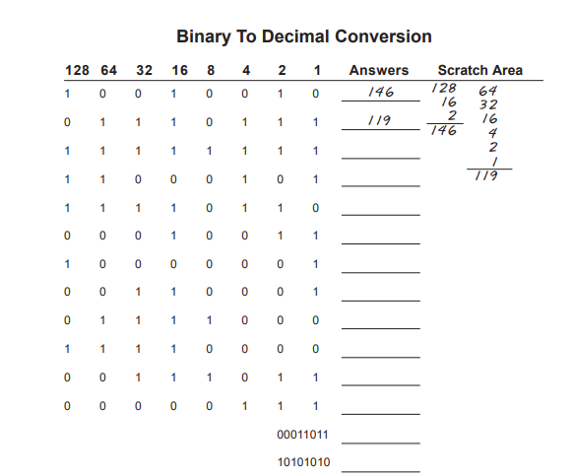

**Solution:**

1.10010010 ->146

2.01110111 ->119

3.11111111 ->255

4.11000101 ->197

5.11110110 ->246

6.00010011 ->19

7.10000001 - >129

8.00110001 ->49

9.01111000 ->120

10.11110000 ->240

11.00111011 ->59

12.00000111 ->7

13.00011011 ->27

14.10101010 ->170

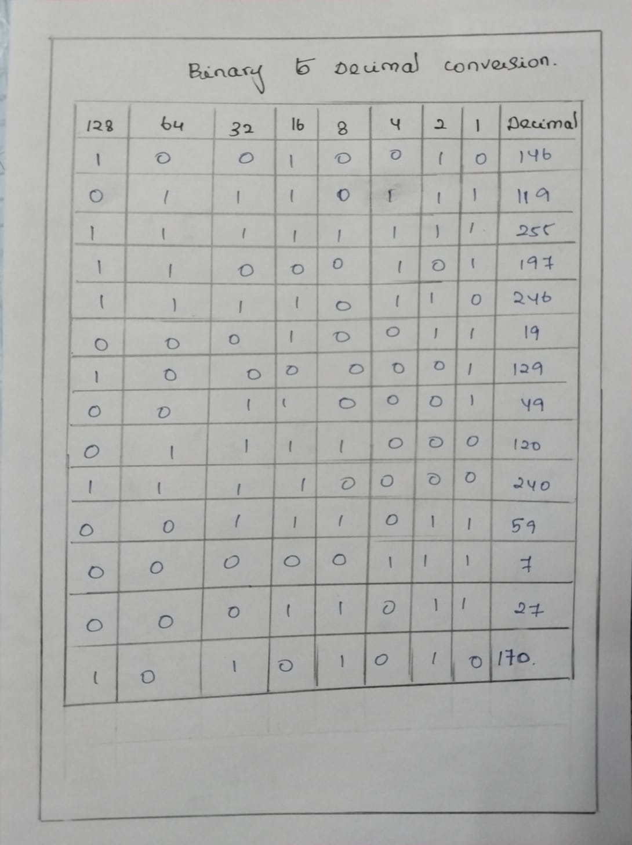

**2.Decimal to Binary.**

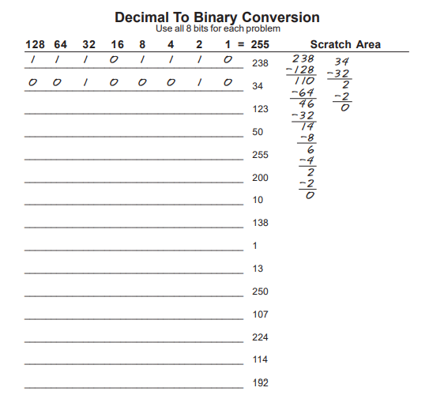

**Solution:**

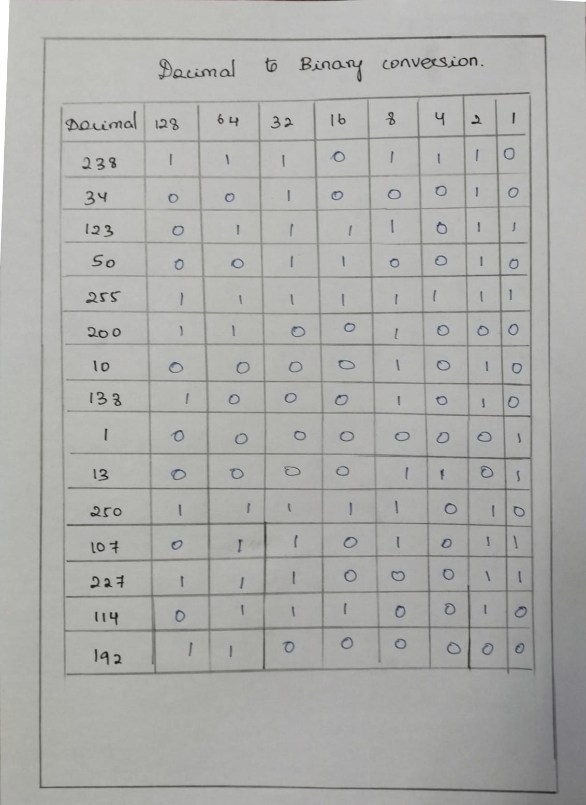

**3.Address of classes identification.**

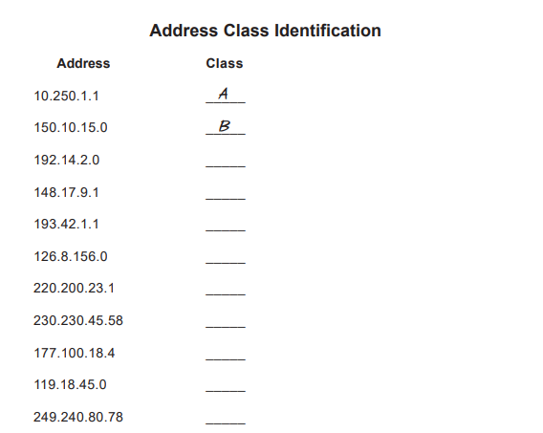

**Solution:**

**A ->1-126**

**B ->128-191**

**C ->192-223**

**D ->224-239**

**E ->240-255**

1. 10.250.1.1

- First Octet: 10

- Class A (1-126)

2. 150.10.15.0

- First Octet: 150

- Class B (128-191)

3. 192.14.2.0

- First Octet: 192

- Class C (192-223)

4. 148.17.9.1

- First Octet: 148

- Class B (128-191)

5. 193.42.1.1

- First Octet: 193

- Class C (192-223)

6. 126.8.156.0

- First Octet: 126

- Class A (1-126)

7. 220.200.23.1

- First Octet: 220

- Class C (192-223)

8. 230.230.45.58

- First Octet: 230

- Class D (224-239, used for multicast)

9. 177.100.18.4

- First Octet: 177

- Class B (128-191)

10. 119.18.45.0

- First Octet: 119

- Class A (1-126)

11. 249.240.80.78

- First Octet: 249

- Class E (240-255, used for experimental purposes

**4.Network and Host Position Circle.**



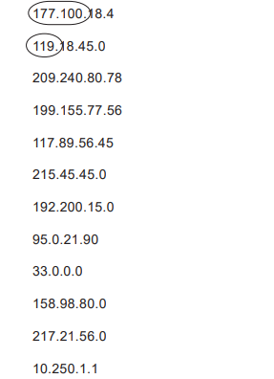

**Solution:**

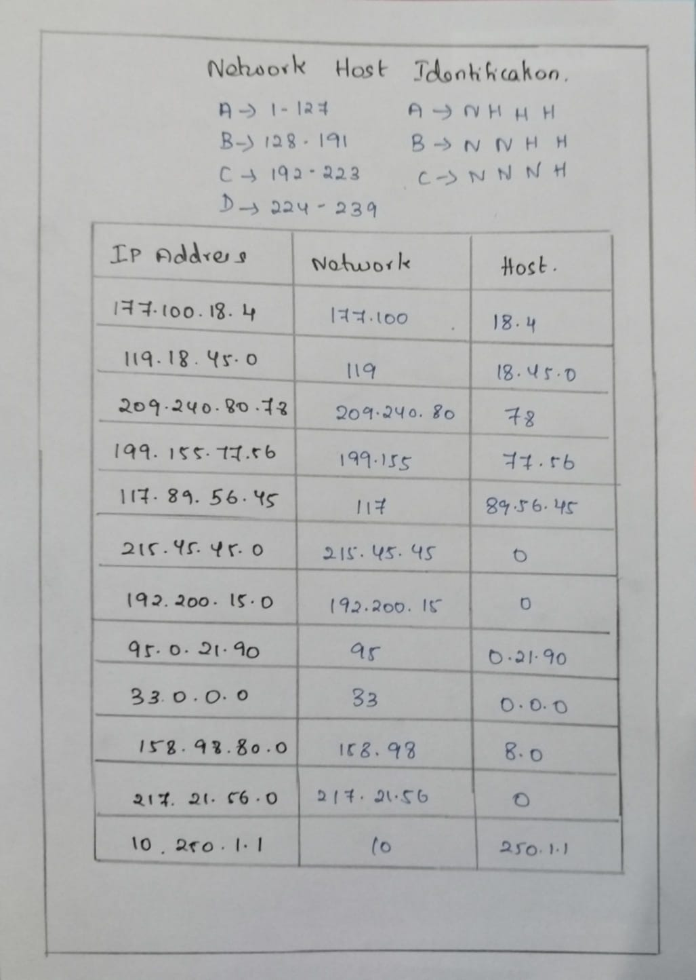

**Date:05/06/2024**

**1.Network Address.**

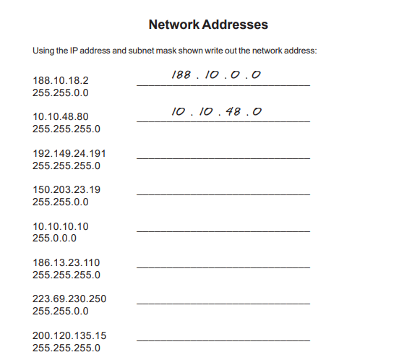

**Solution:**

**Network Addresses**

1. 188.10.18.2 / 255.255.0.0

- IP Address: 188.10.18.2

- Subnet Mask: 255.255.0.0

**- Network Address: 188.10.0.0**

2. 10.10.48.80 / 255.255.255.0

- IP Address: 10.10.48.80

- Subnet Mask: 255.255.255.0

- **Network Address: 10.10.48.0**

3. 192.149.24.191 / 255.255.255.0

- IP Address: 192.149.24.191

- Subnet Mask: 255.255.255.0

- **Network Address: 192.149.24.0**

4. 150.203.23.19 / 255.255.0.0

- IP Address: 150.203.23.19

- Subnet Mask: 255.255.0.0

- **Network Address: 150.203.0.0**

5. 10.10.10.10 / 255.0.0.0

- IP Address: 10.10.10.10

- Subnet Mask: 255.0.0.0

- **Network Address: 10.0.0.0**

6. 186.13.23.110 / 255.255.255.0

- IP Address: 186.13.23.110

- Subnet Mask: 255.255.255.0

- **Network Address: 186.13.23.0**

7. 223.69.230.250 / 255.255.0.0

- IP Address: 223.69.230.250

- Subnet Mask: 255.255.0.0

- **Network Address: 223.69.0.0**

8. 200.120.135.15 / 255.255.255.0

- IP Address: 200.120.135.15

- Subnet Mask: 255.255.255.0

- **Network Address: 200.120.135.0**

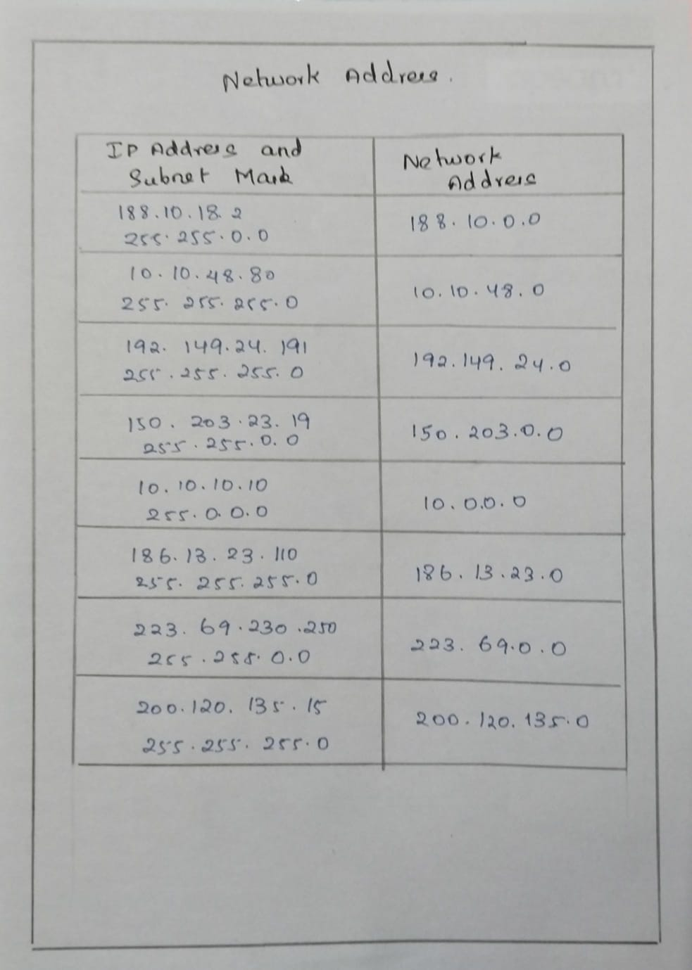

**2.Host Address.**

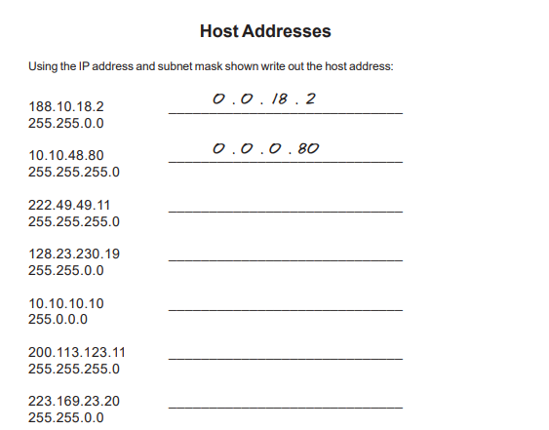

**Solution:**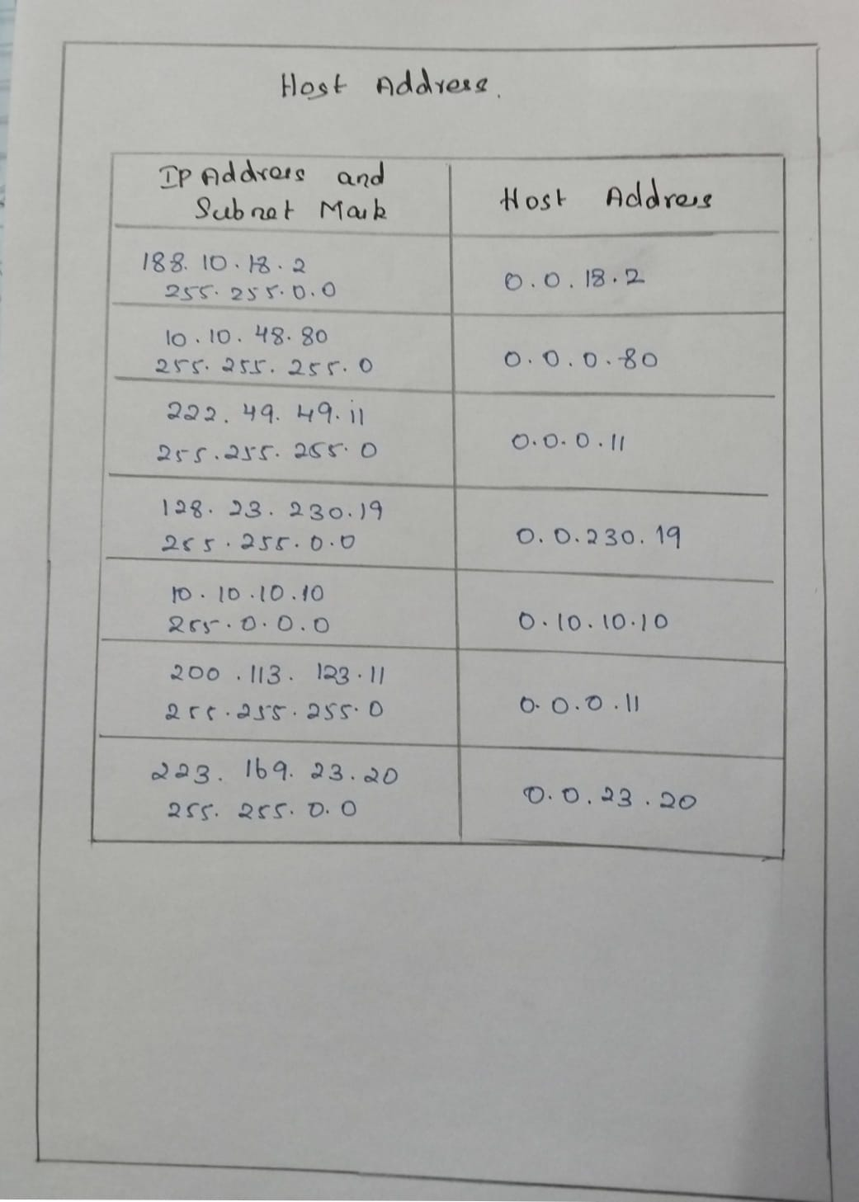

**3.Default Subnet Masks:**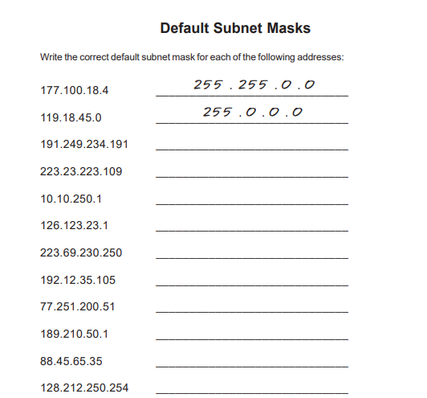

**Solution:**

1. 177.100.18.4

- Class B

**- Default Subnet Mask: 255.255.0.0**

2. 119.18.45.0

- Class A

**- Default Subnet Mask: 255.0.0.0**

3. 191.249.234.191

- Class B

- **Default Subnet Mask: 255.255.0.0**

4. 223.23.223.109

- Class C

- **Default Subnet Mask: 255.255.255.0**

5. 10.10.250.1

- Class A

- **Default Subnet Mask: 255.0.0.0**

6. 126.123.23.1

- Class A

- **Default Subnet Mask: 255.0.0.0**

7. 223.69.230.250

- Class C

- **Default Subnet Mask: 255.255.255.0**

8. 192.12.35.105

- Class C

- **Default Subnet Mask: 255.255.255.0**

9. 77.251.200.51

- Class A

- **Default Subnet Mask: 255.0.0.0**

10. 189.210.50.1

- Class B

- **Default Subnet Mask: 255.255.0.0**

11. 88.45.65.35

- Class A

- **Default Subnet Mask: 255.0.0.0**

12. 128.212.250.254

- Class B

- Default Subnet Mask: 255.255.0.0

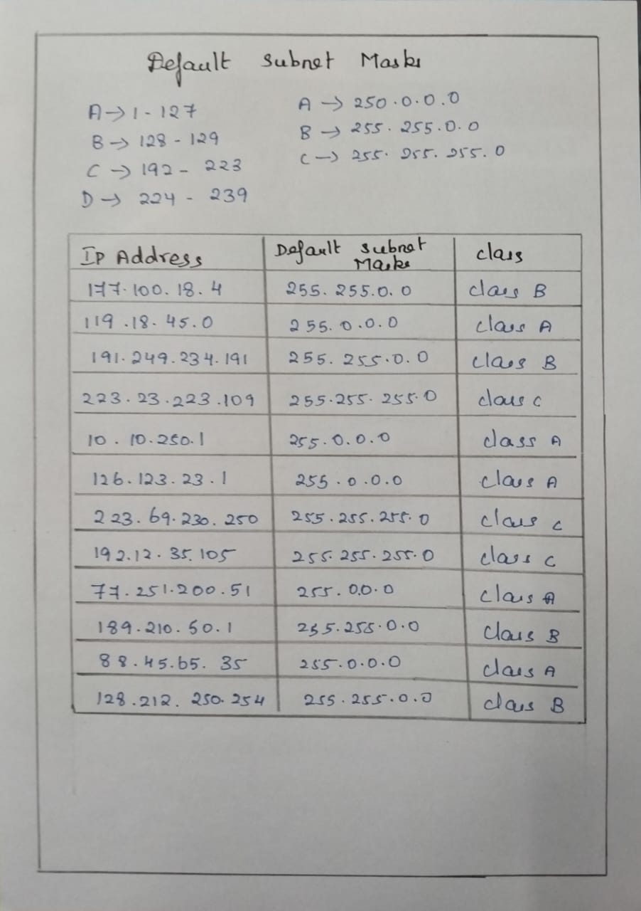

**4.Broadcast.**

**Using this ip address and subnet mask find broadcast address**

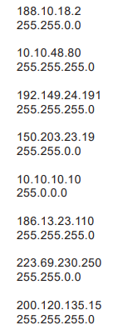

**Solution:**

**Broadcast Address:**

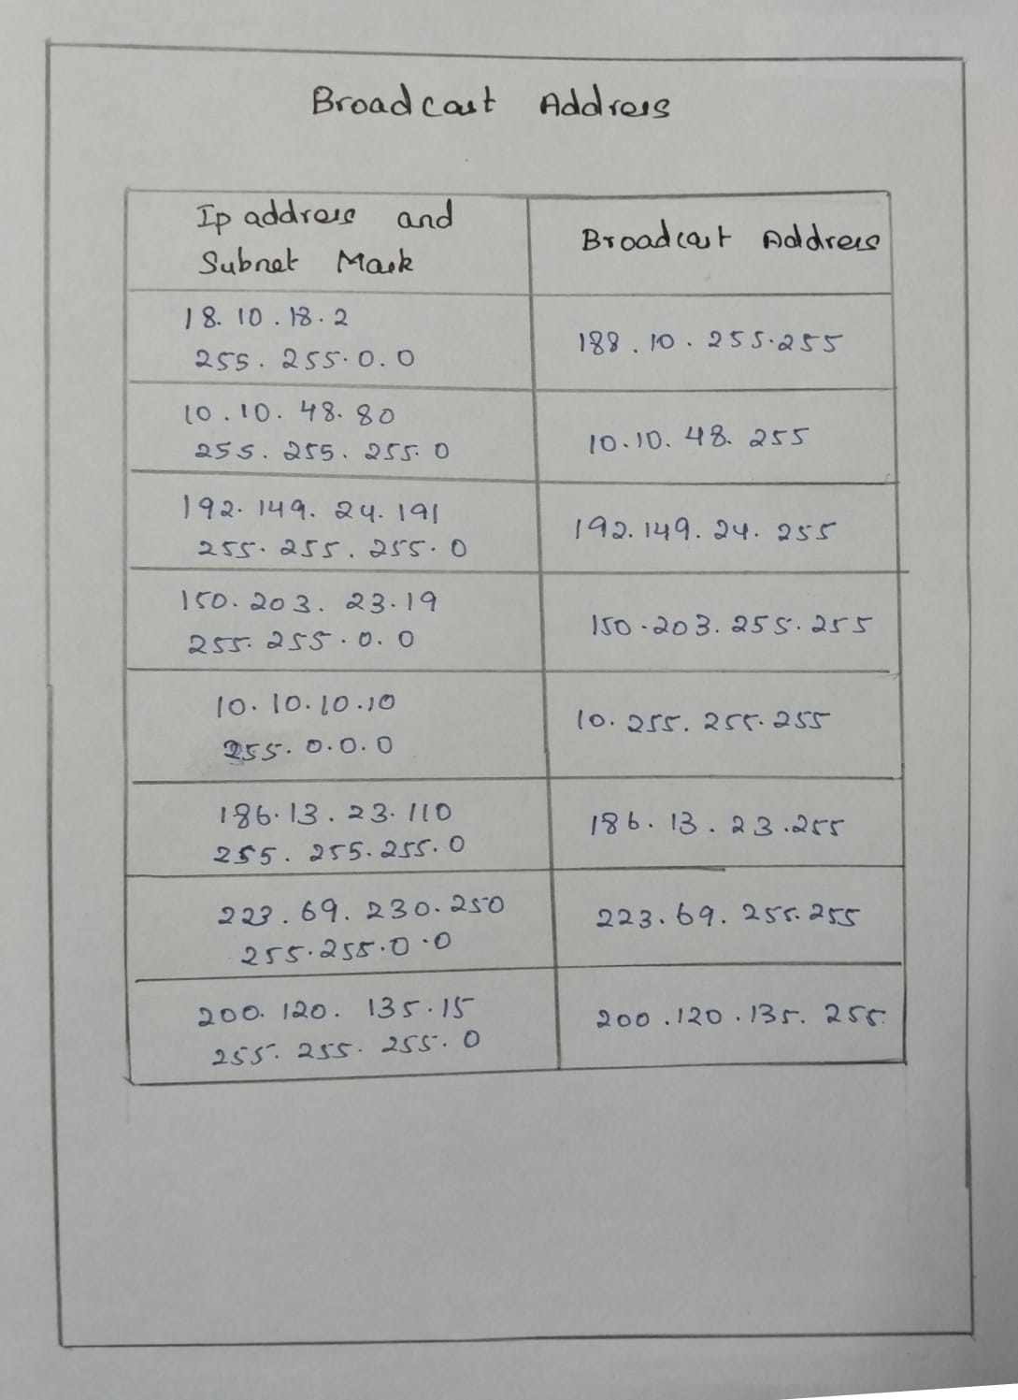

**5.** 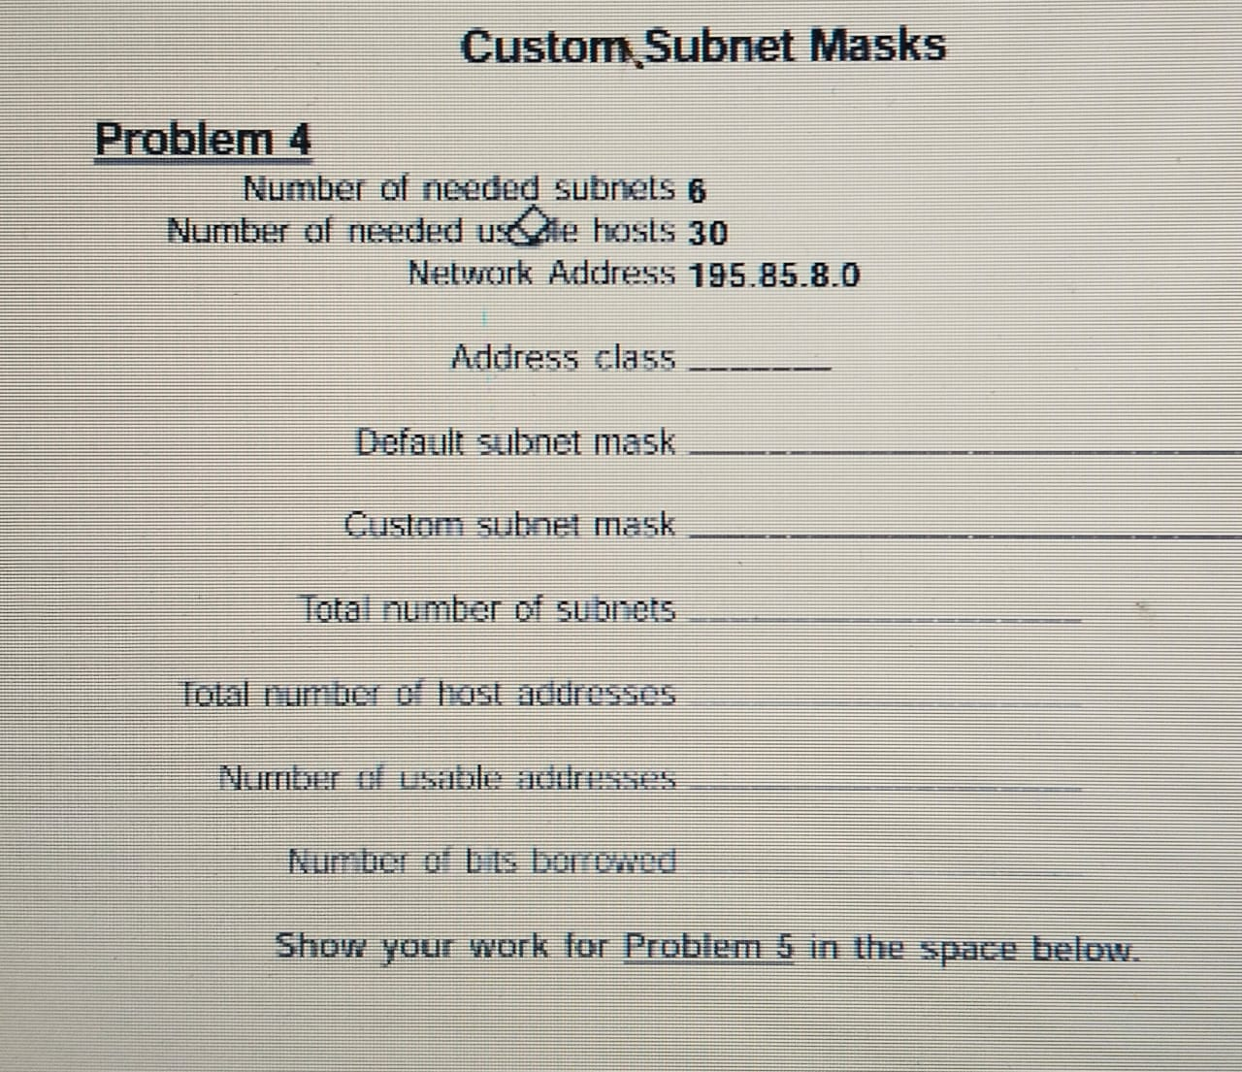

**Solution:**

Address class:C

Default subnet mask: 255.255.255.0

Custom subnet mask: 255.255.255.224

Total number of subnets: 8

Total number of host addresses: 32

Number of usable addresses: 30

Number of bits borrowed: 3

**Explanation:**

1. Address Class:

Network address:195.85.8.0.

Range of 192-223, it is a Class C address.

Address class: C

2. Default Subnet Mask:

For a Class C address, the default subnet mask is 255.255.255.0.

Default subnet mask: 255.255.255.0

3. Custom Subnet Mask:

(2^3 = 8) (since 3 bits are enough to create 8 subnets, which is more than 6).

(2^5 - 2 = 30) (since 5 bits provide 32 addresses, but 2 are reserved for network and broadcast addresses, leaving 30 usable addresses).

Class C address has 24 network bits and we borrow 3 bits for subnetting, the subnet mask will be:

24 + 3 = 27 bits

Custom subnet mask: 255.255.255.224

4. The Total Number of Subnets:

3 borrowed bits, (2^3 = 8) subnets.

Total number of subnets: 8

5. The Total Number of Host Addresses per Subnet:

5 remaining host bits, (2^5 = 32) addresses per subnet.

Total number of host addresses: 32

6. The Number of Usable Addresses per Subnet:

The number of usable addresses is (2^5 - 2 = 30).

Number of usable addresses: 30

7. Number of Bits Borrowed:

Borrowed 3 bits from the host portion to create subnets.

Number of bits borrowed: 3

**Date:06/06/2024**

**Lab 1 - Connecting the Devices.**

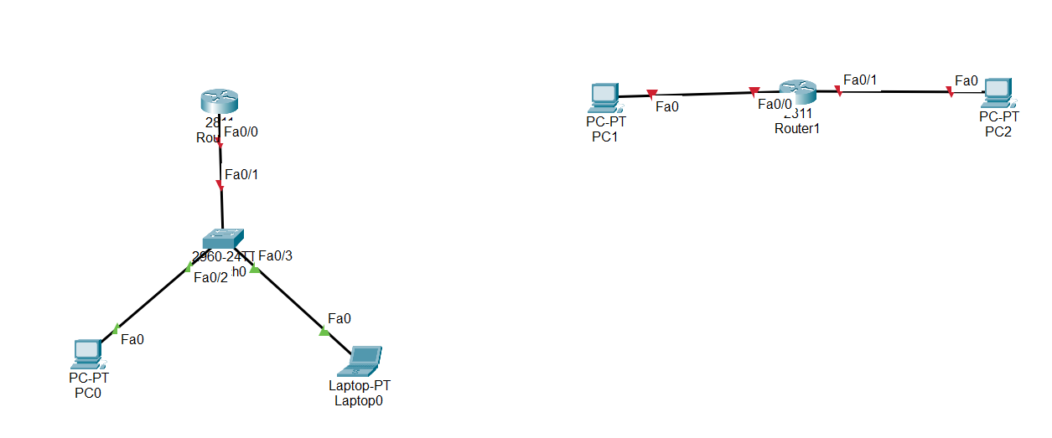

**Lab 2 - IP Address Configuration and Ping check.**

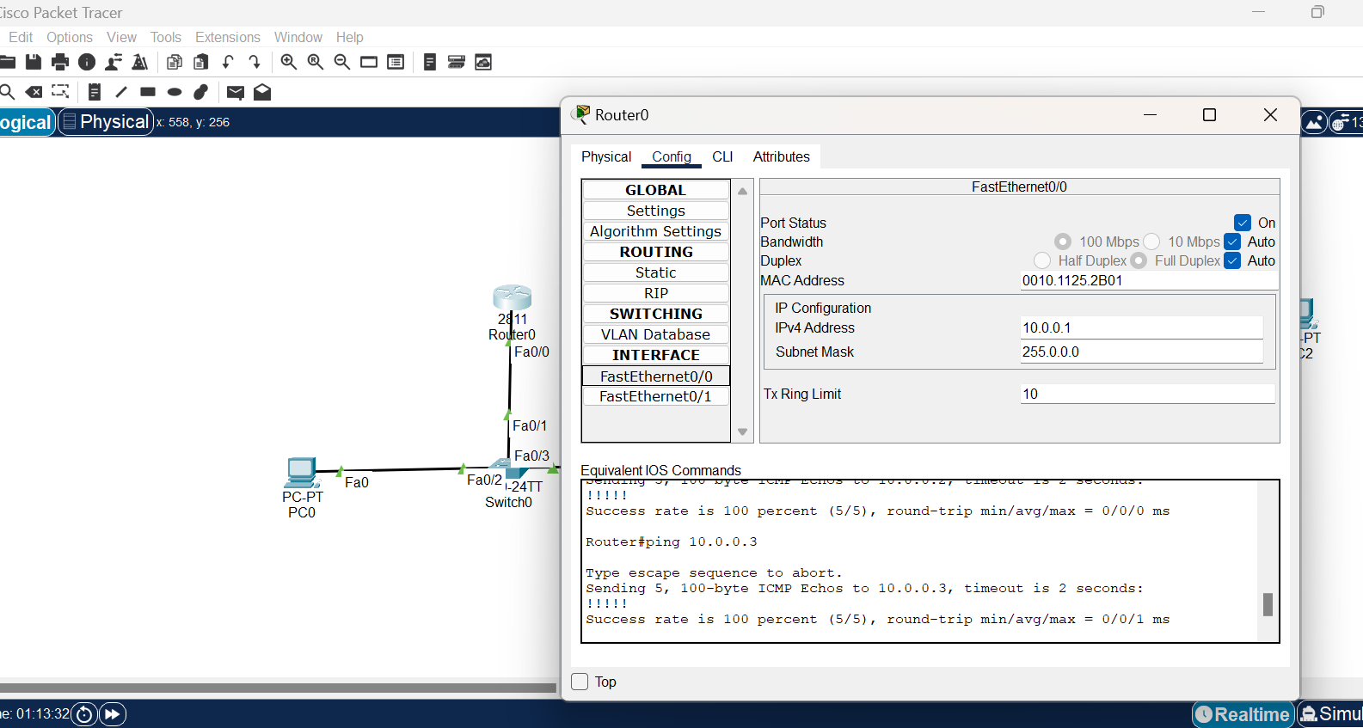

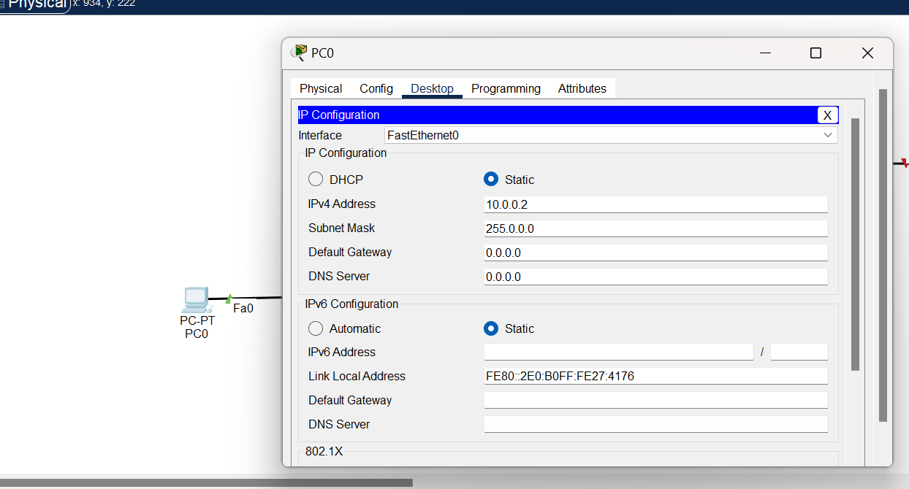

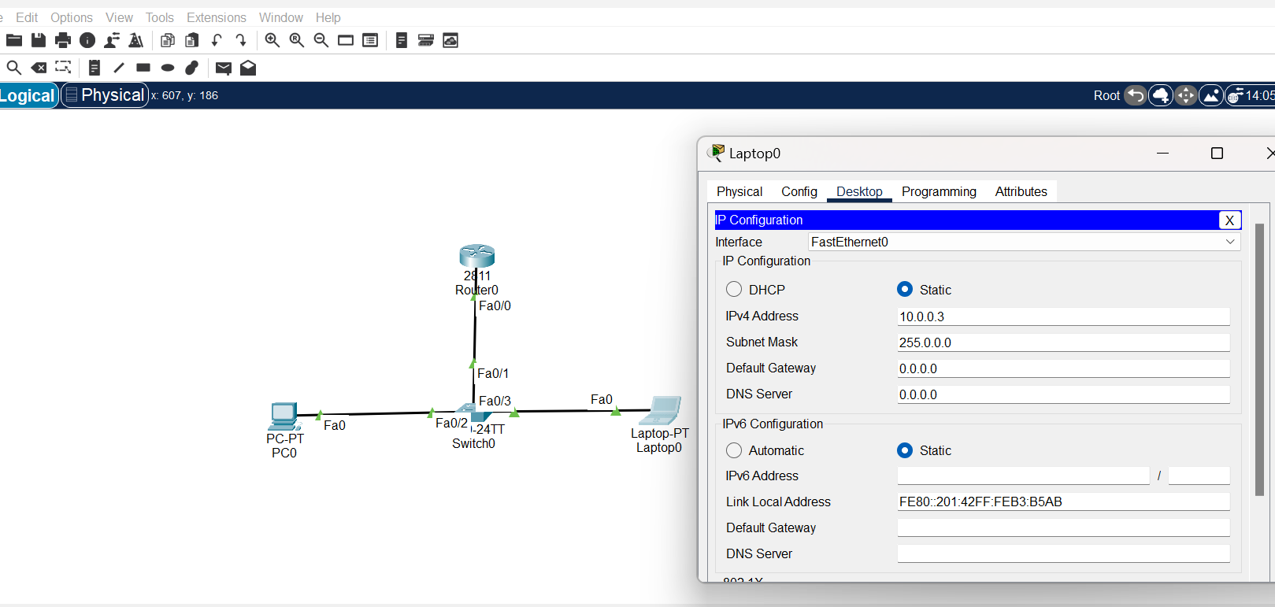

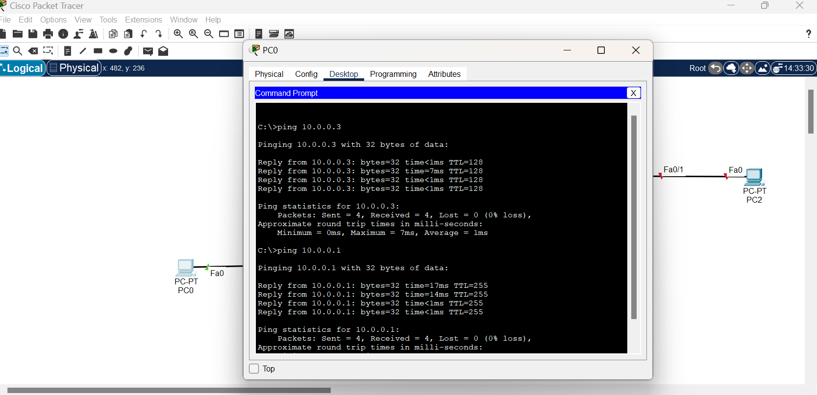

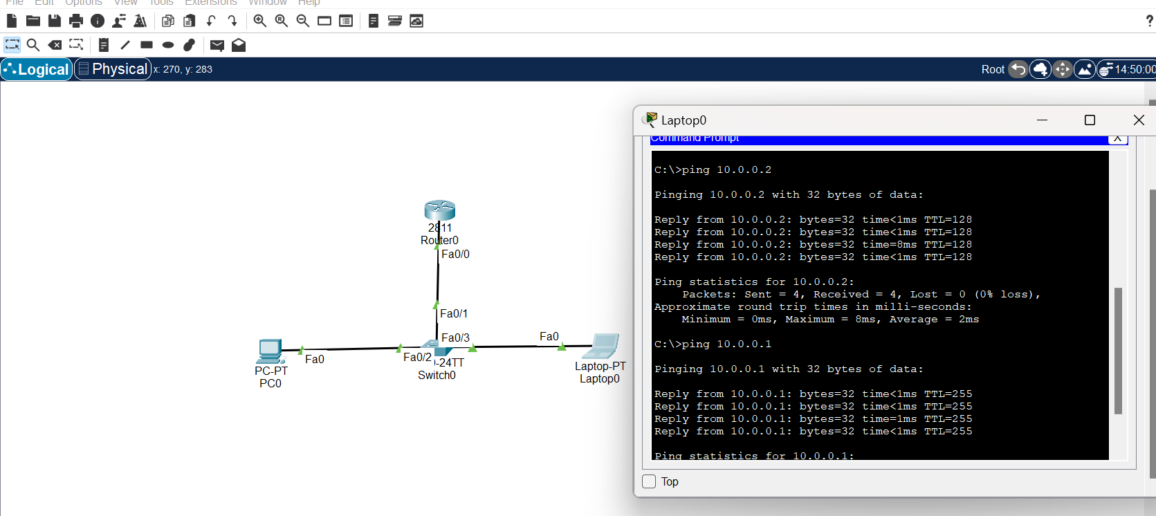

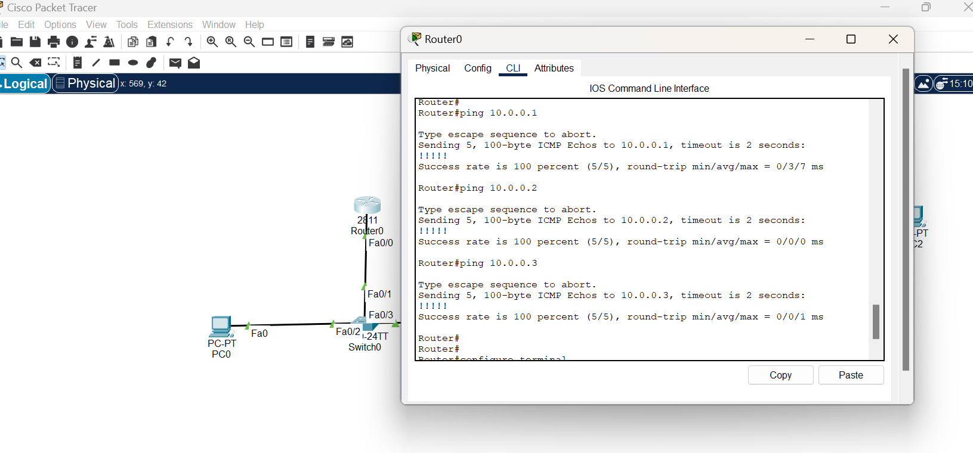

**Lab 3 – Configuration Default Gateway.**

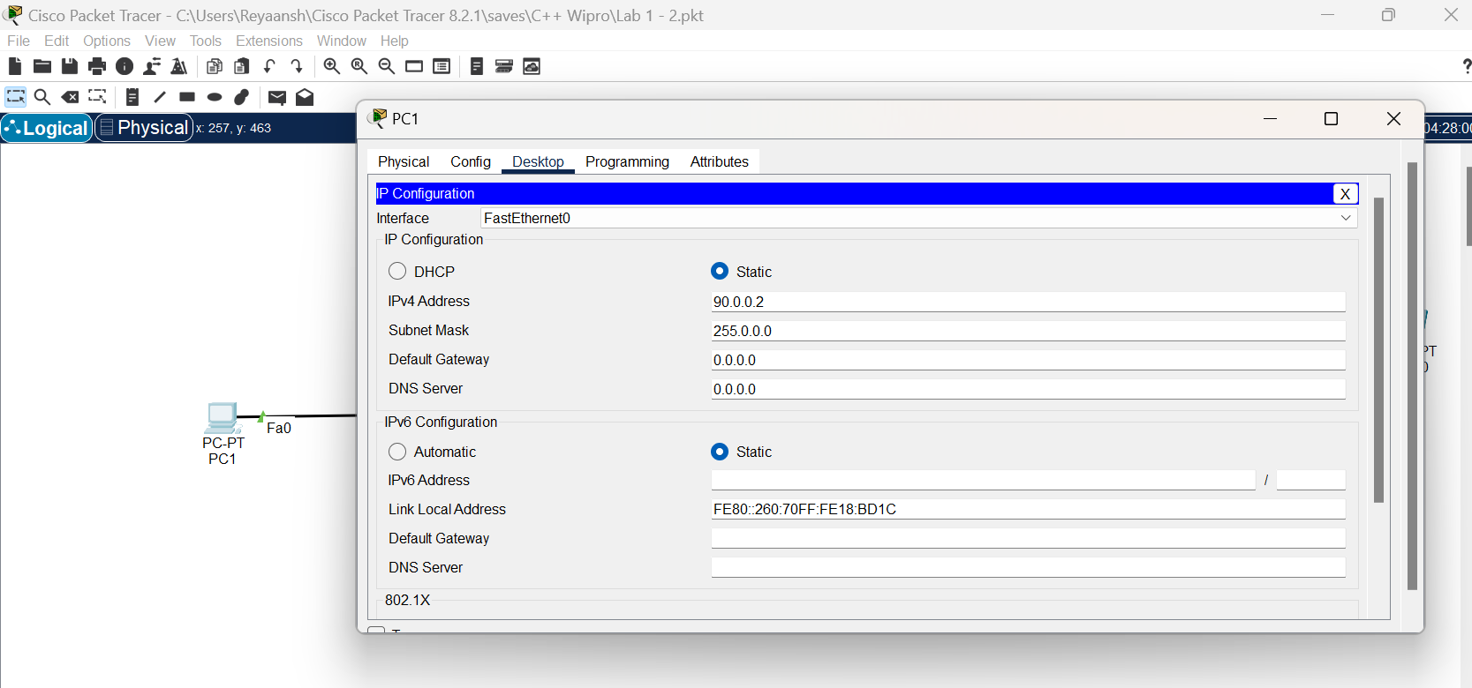

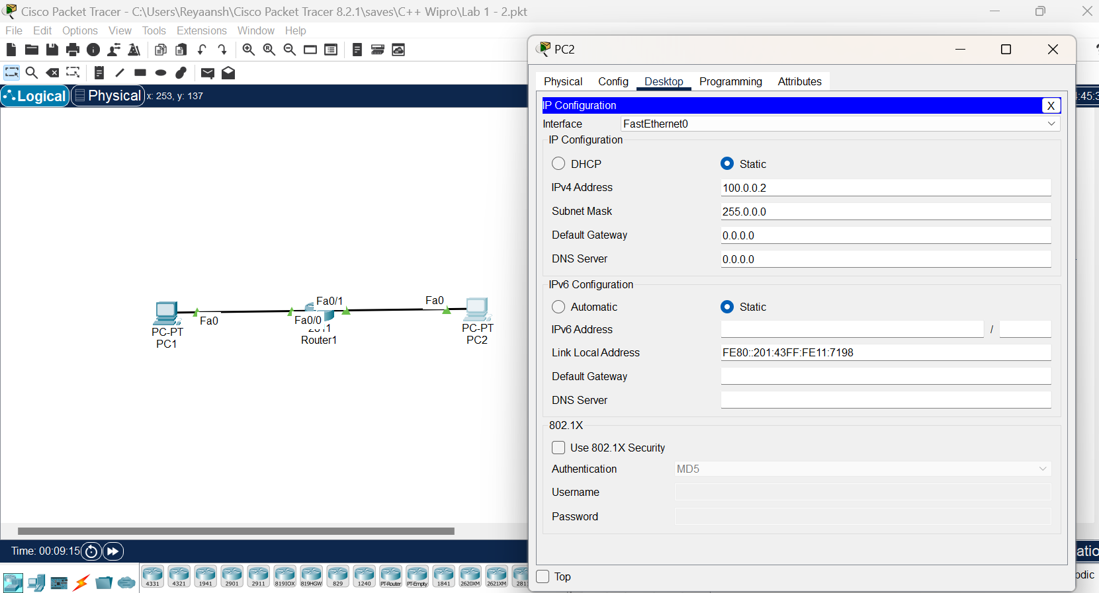

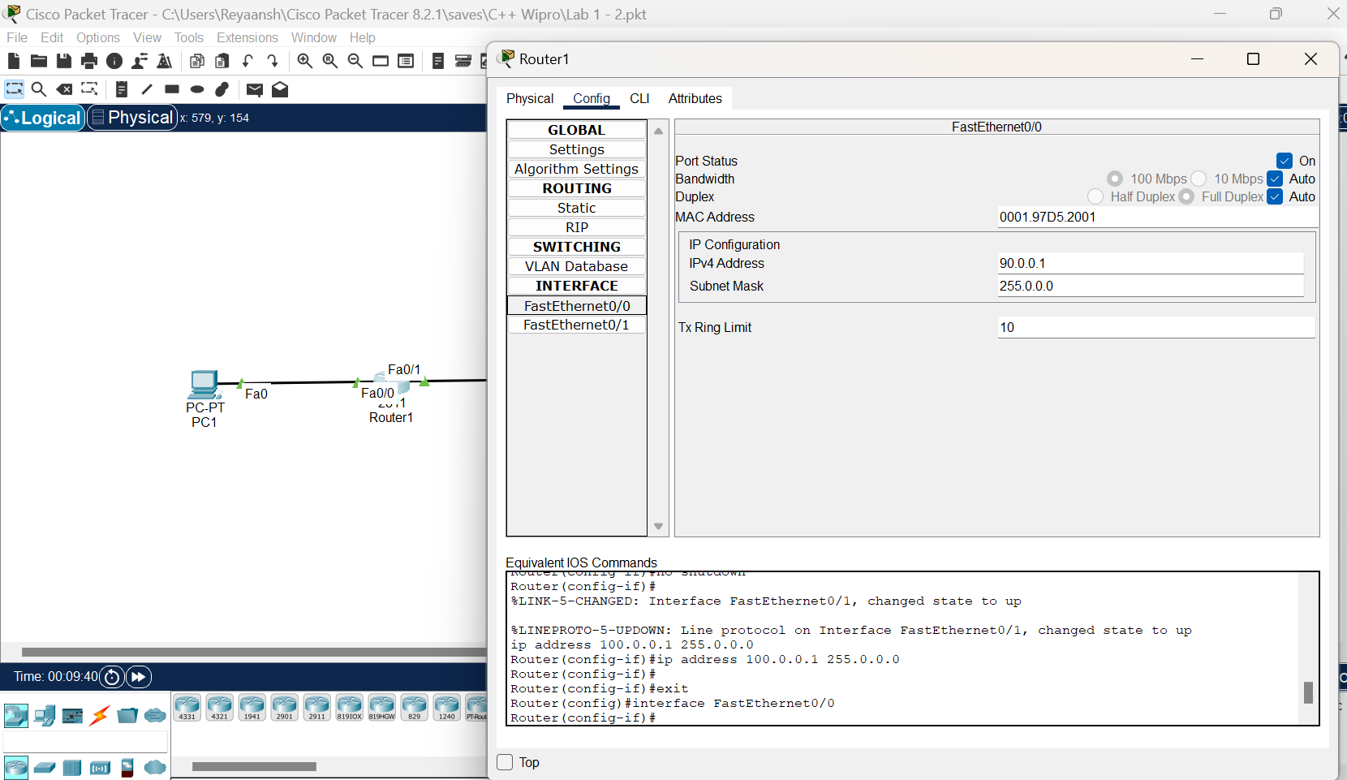

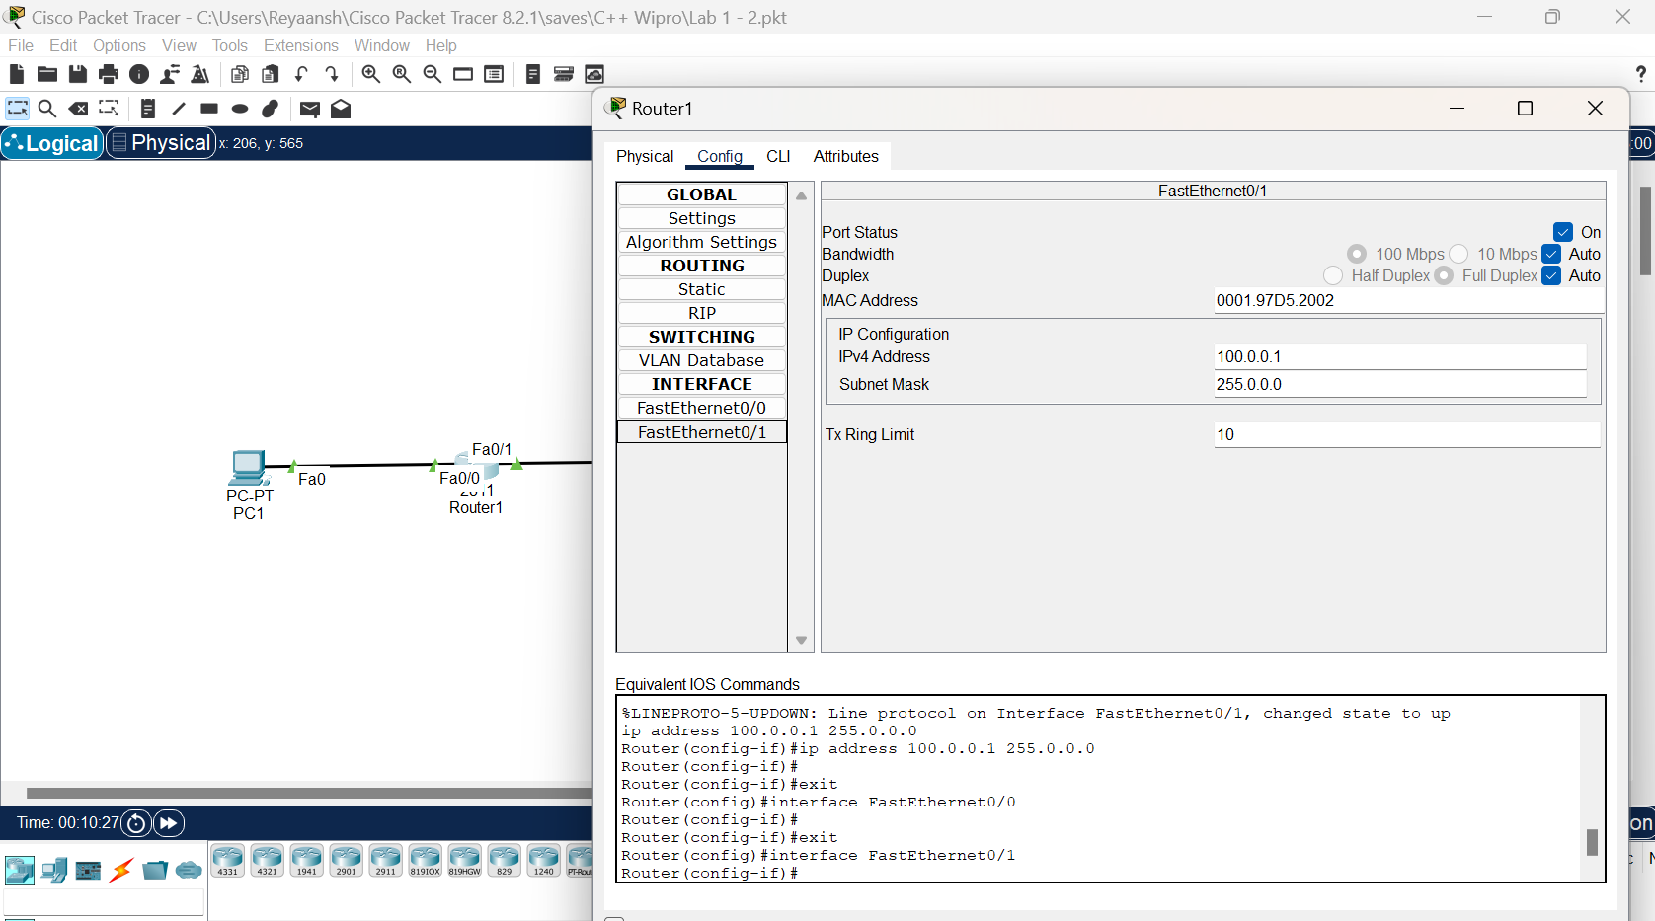

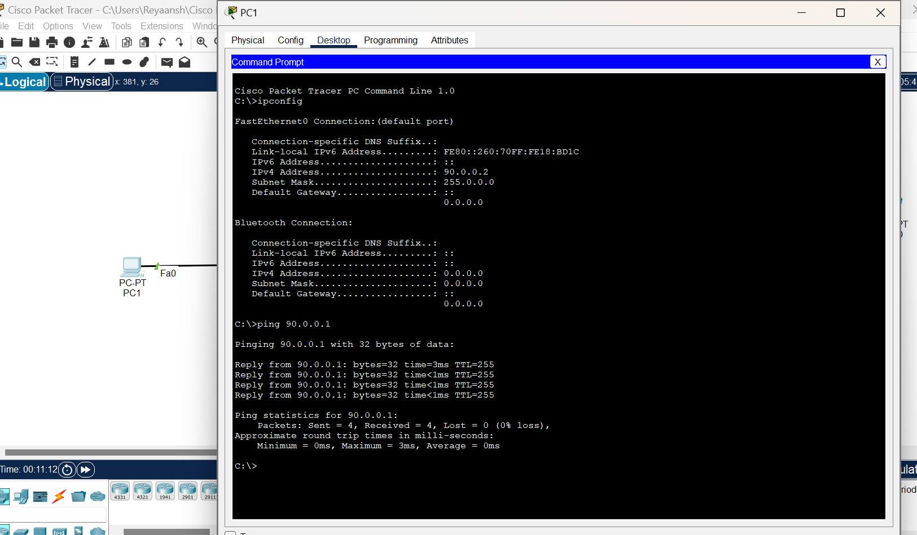

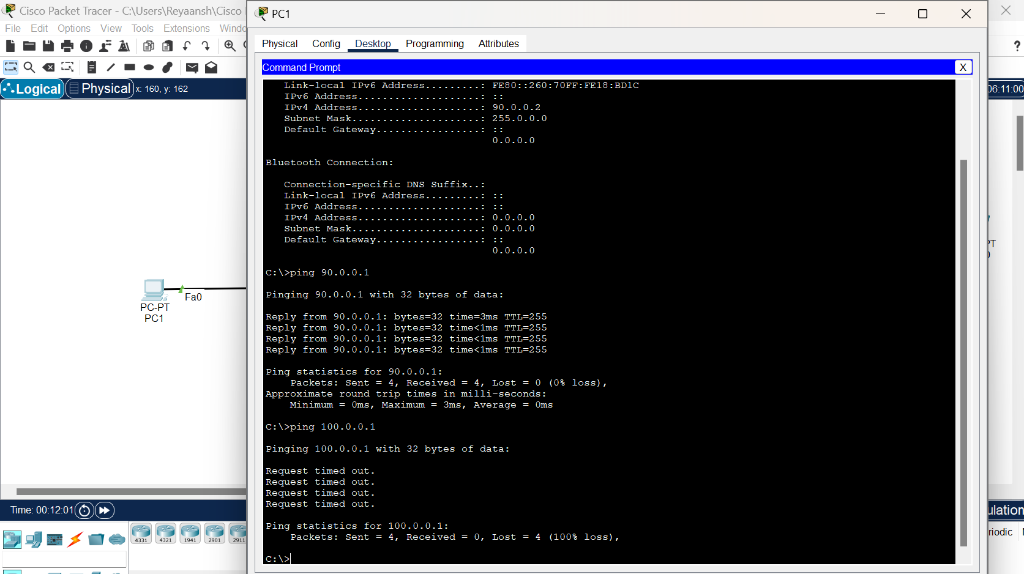

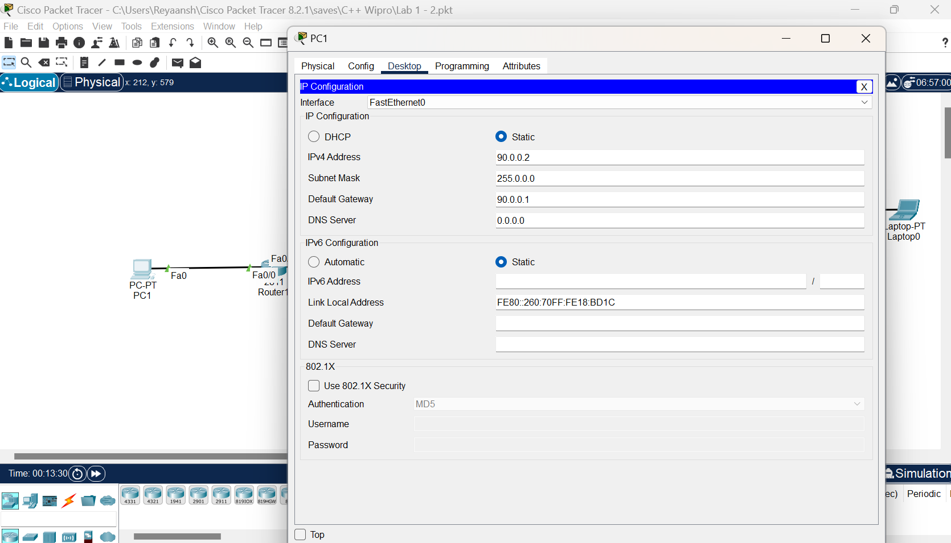

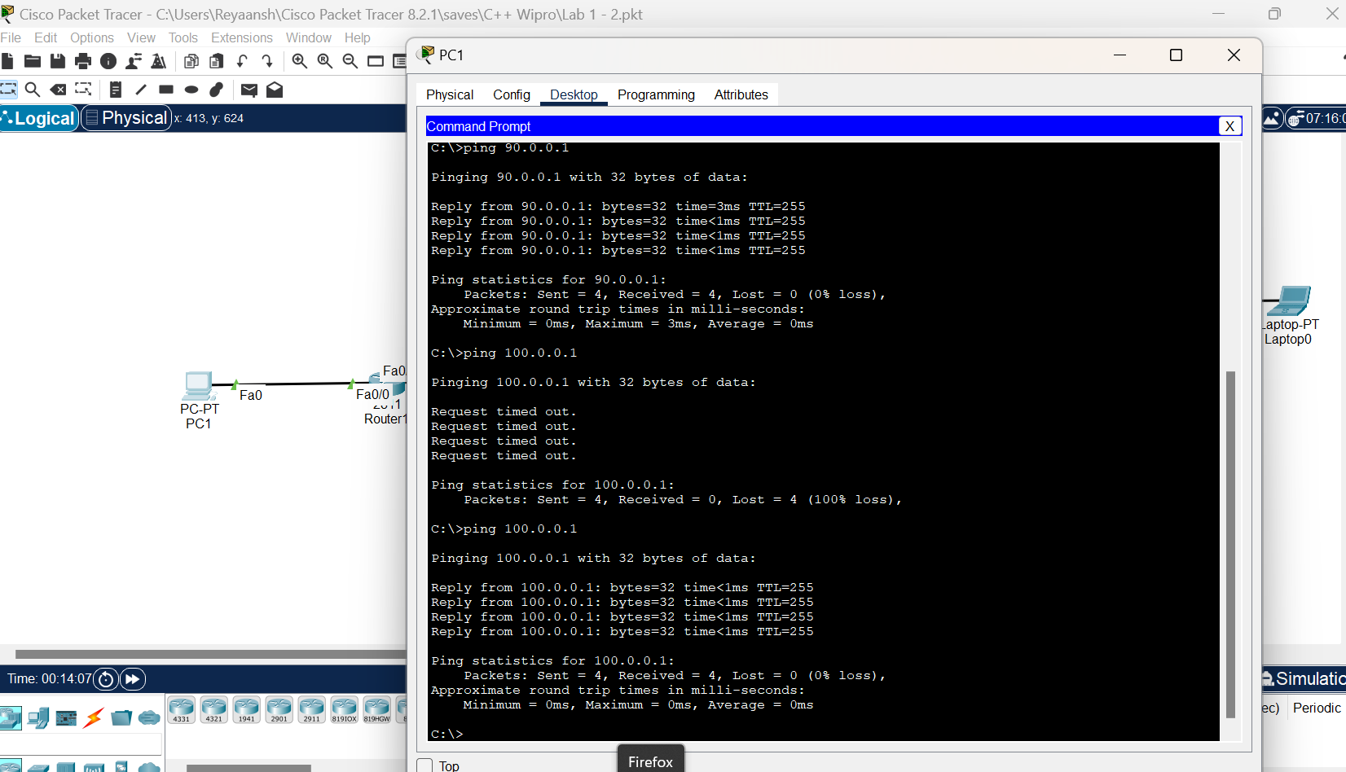

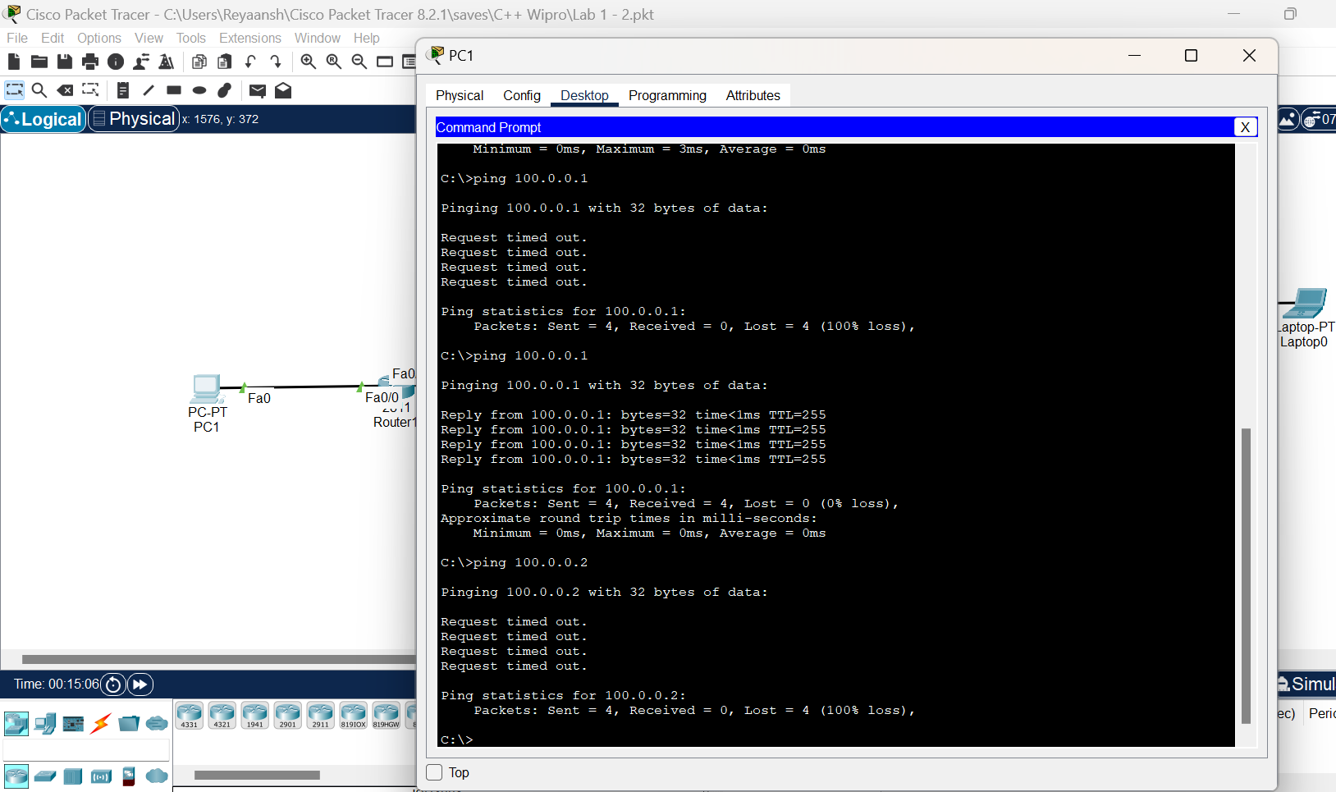

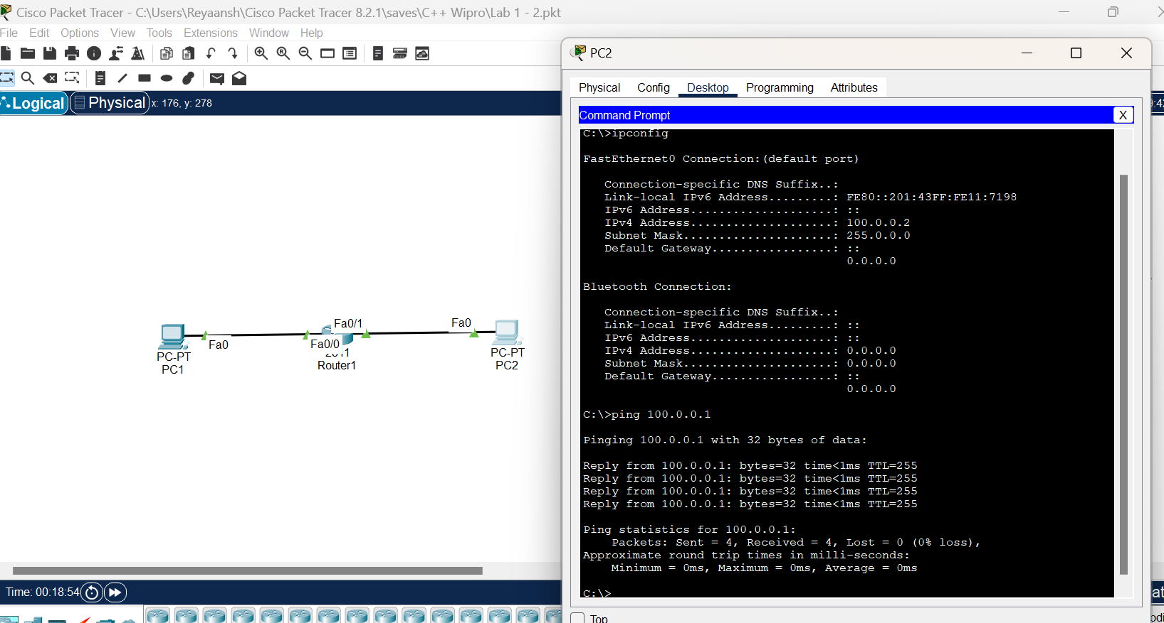

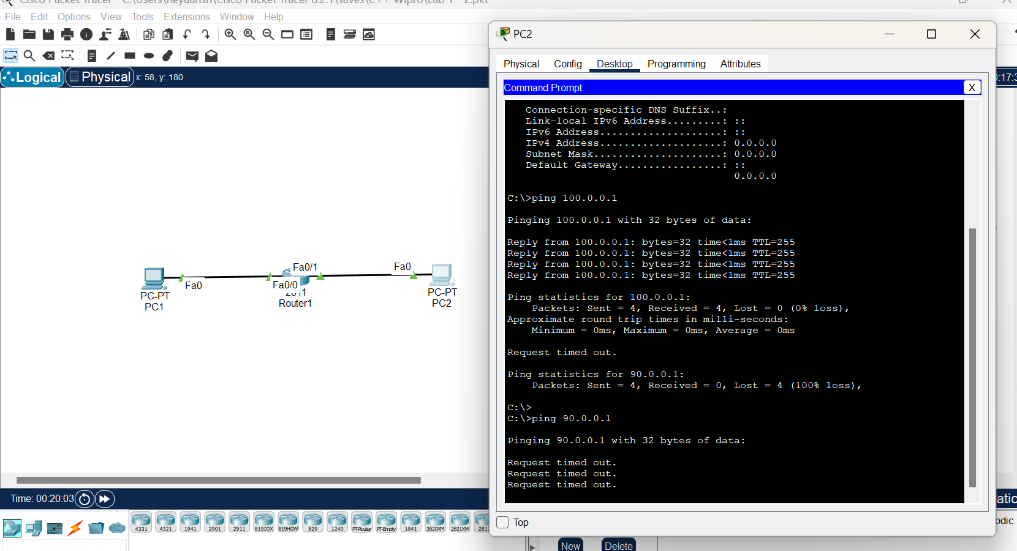

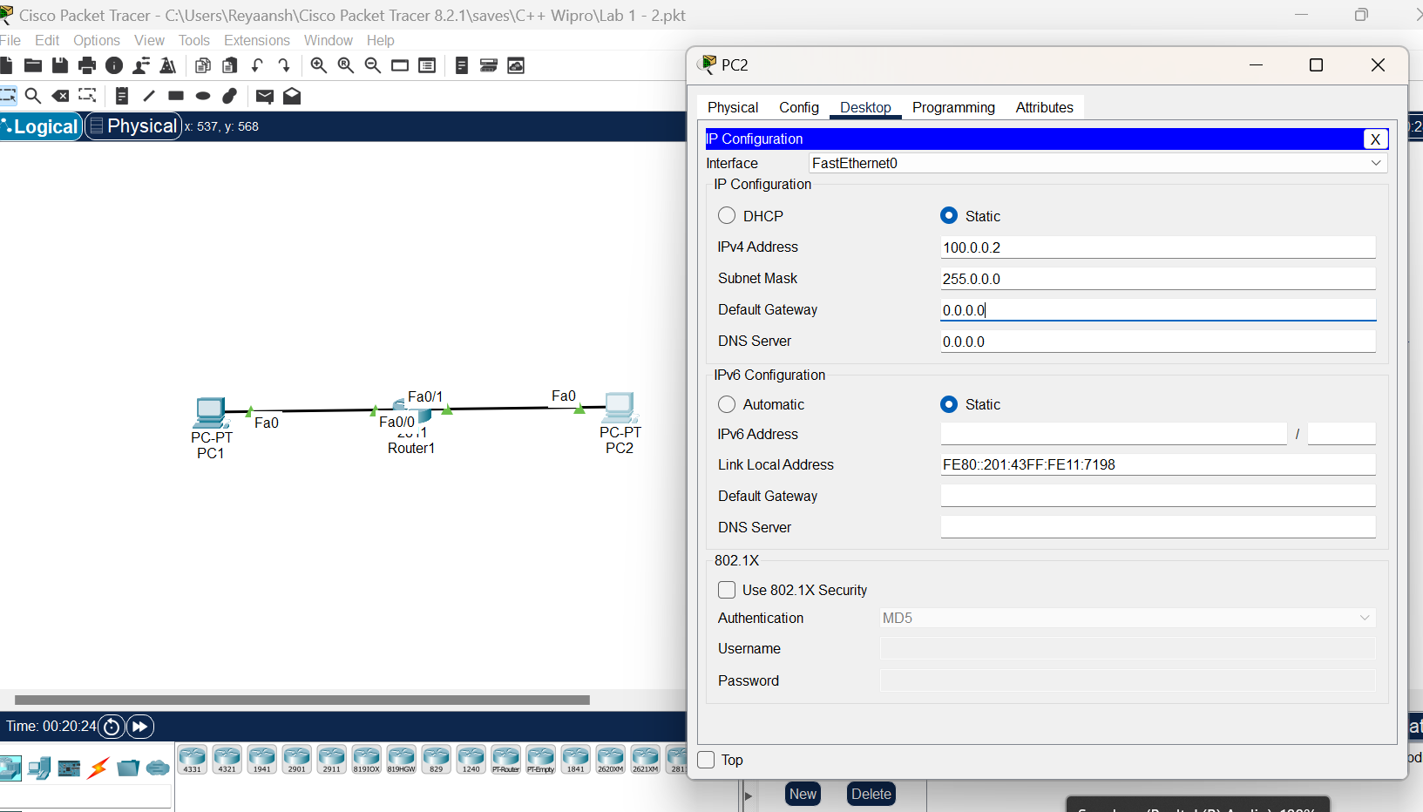

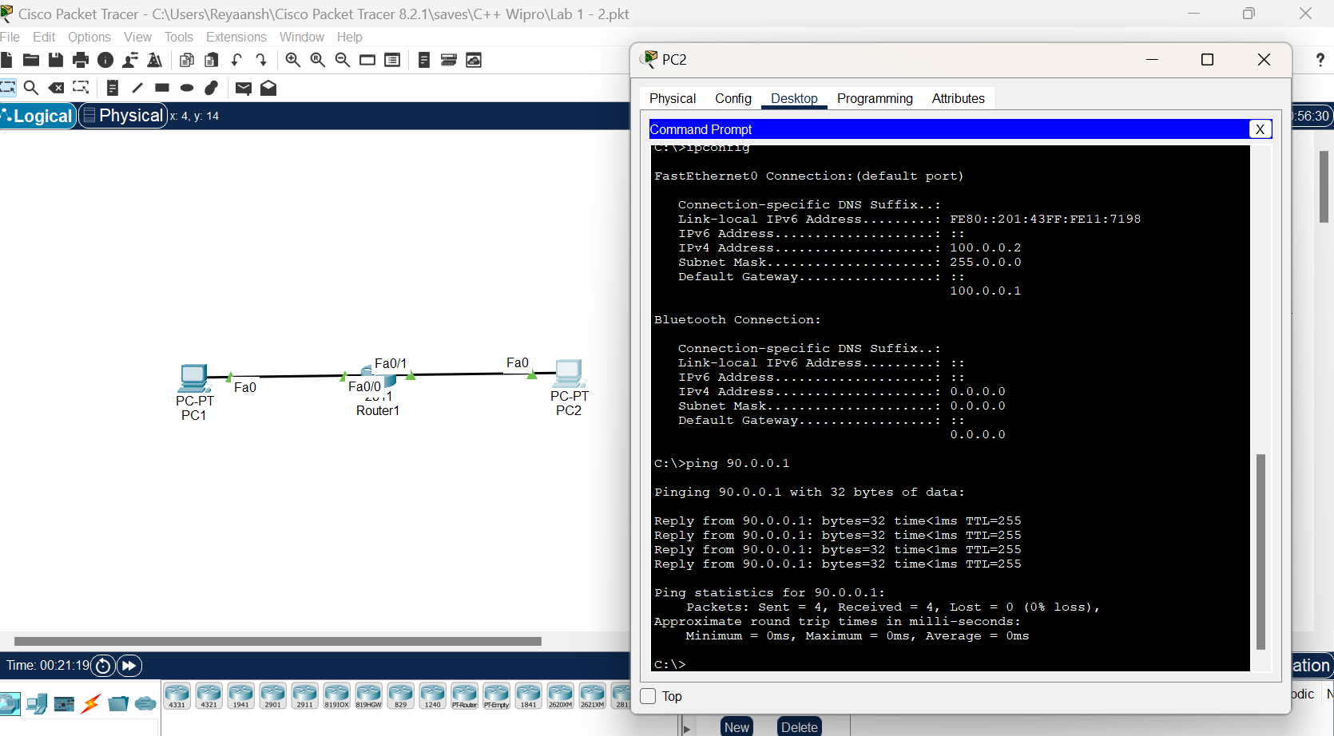

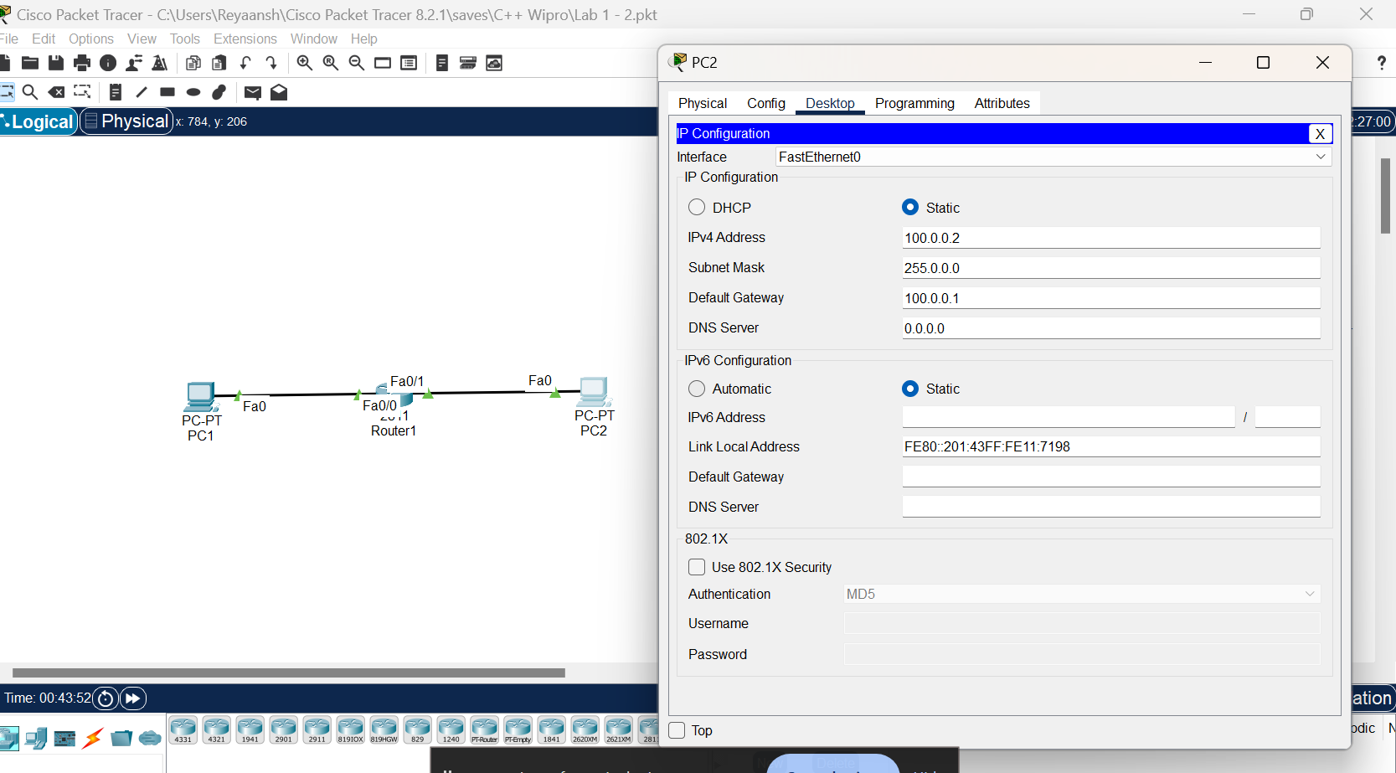

**Date:07/06/24**

**Lab 4 : Static Routing**

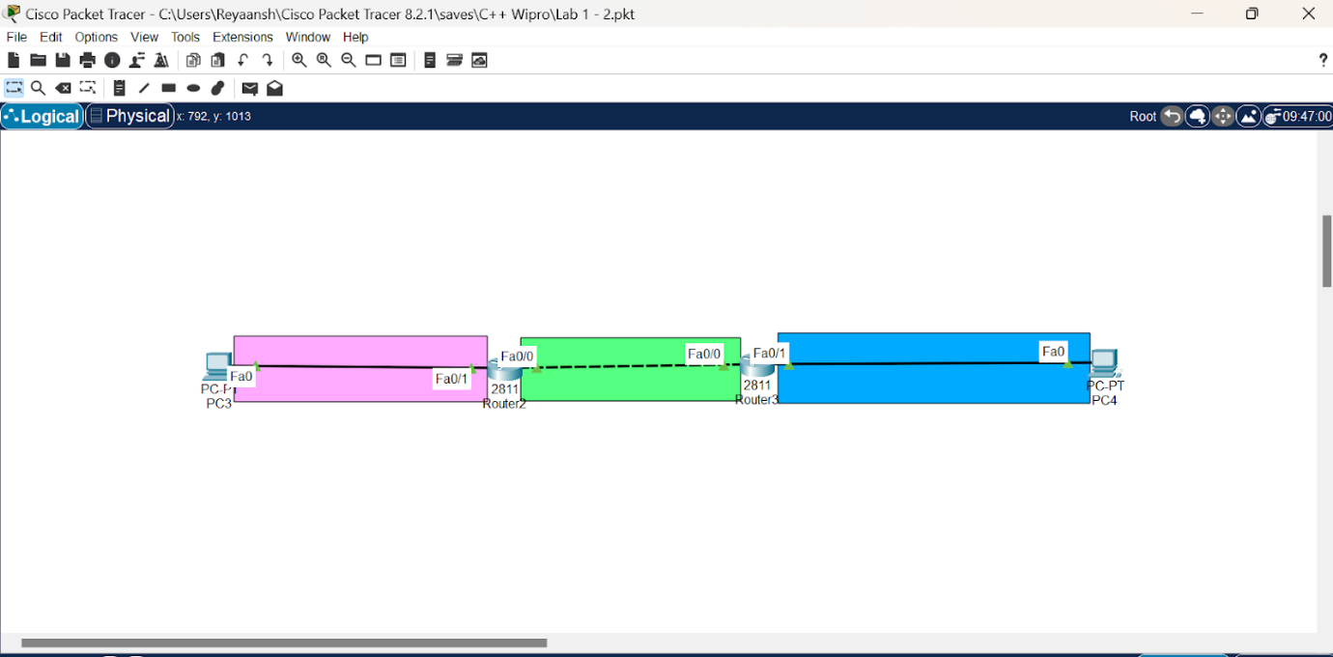

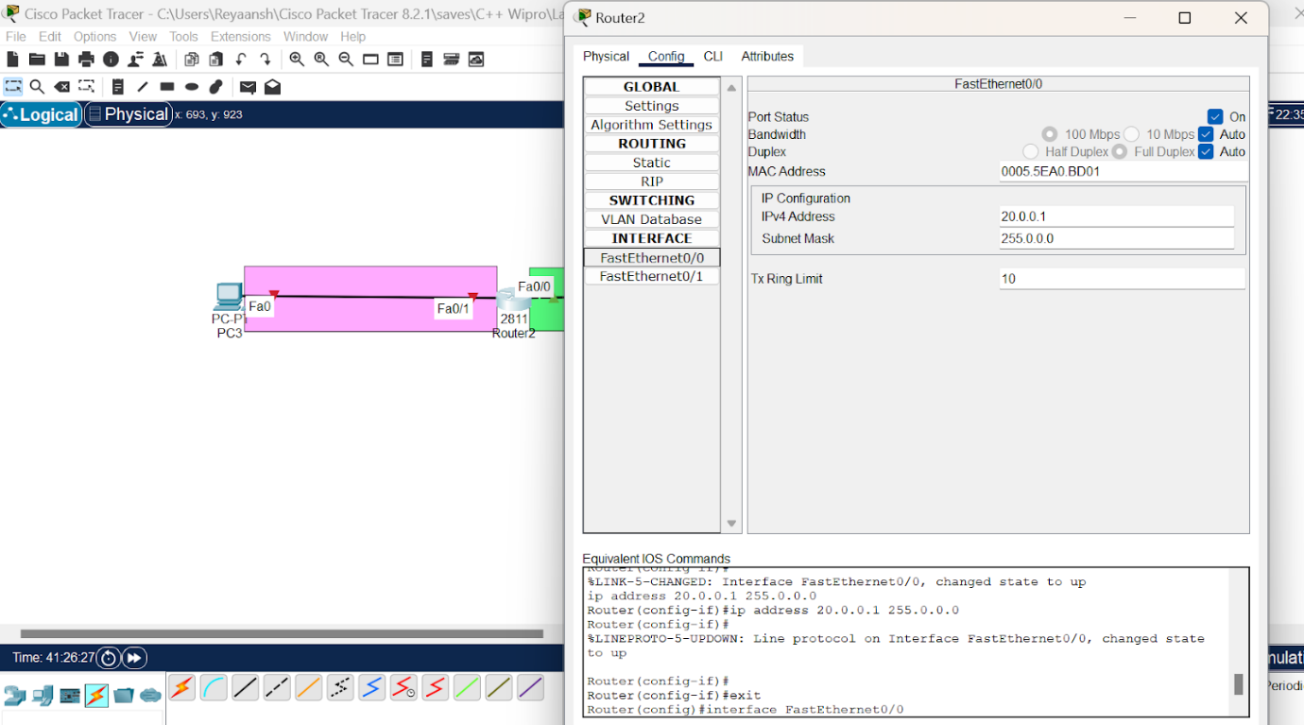

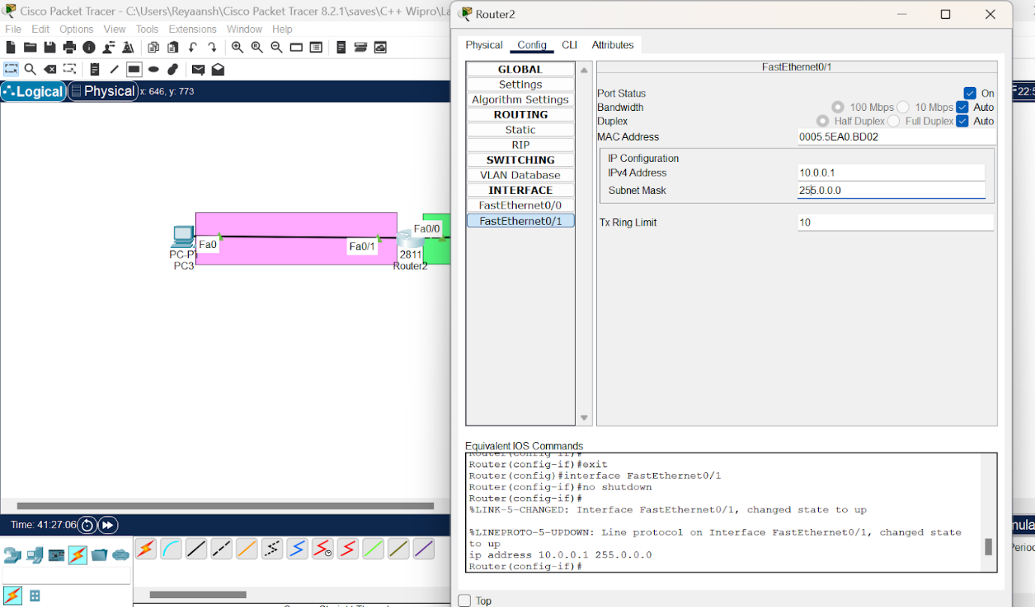

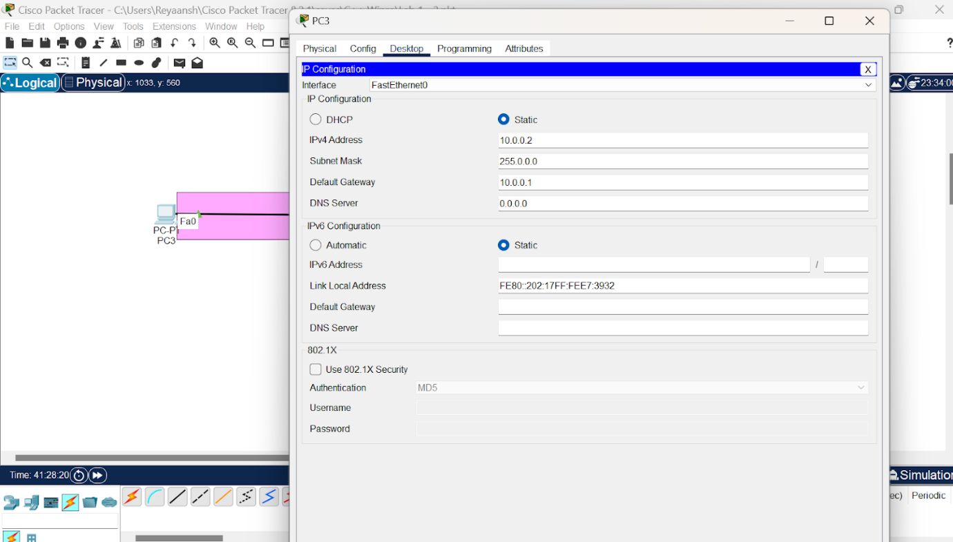

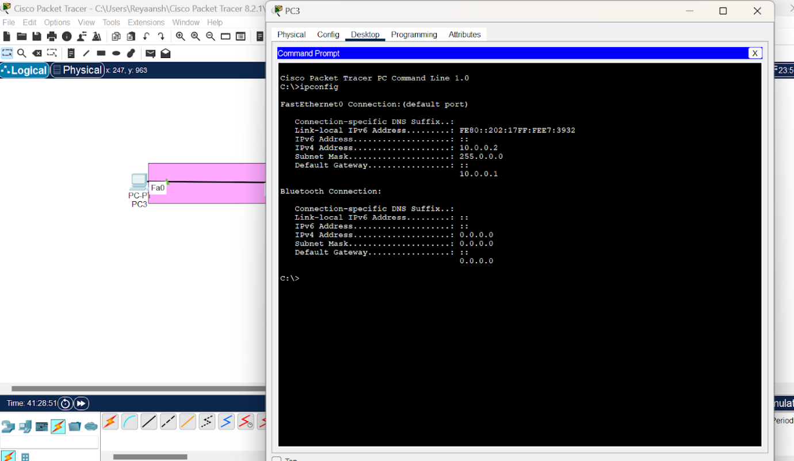

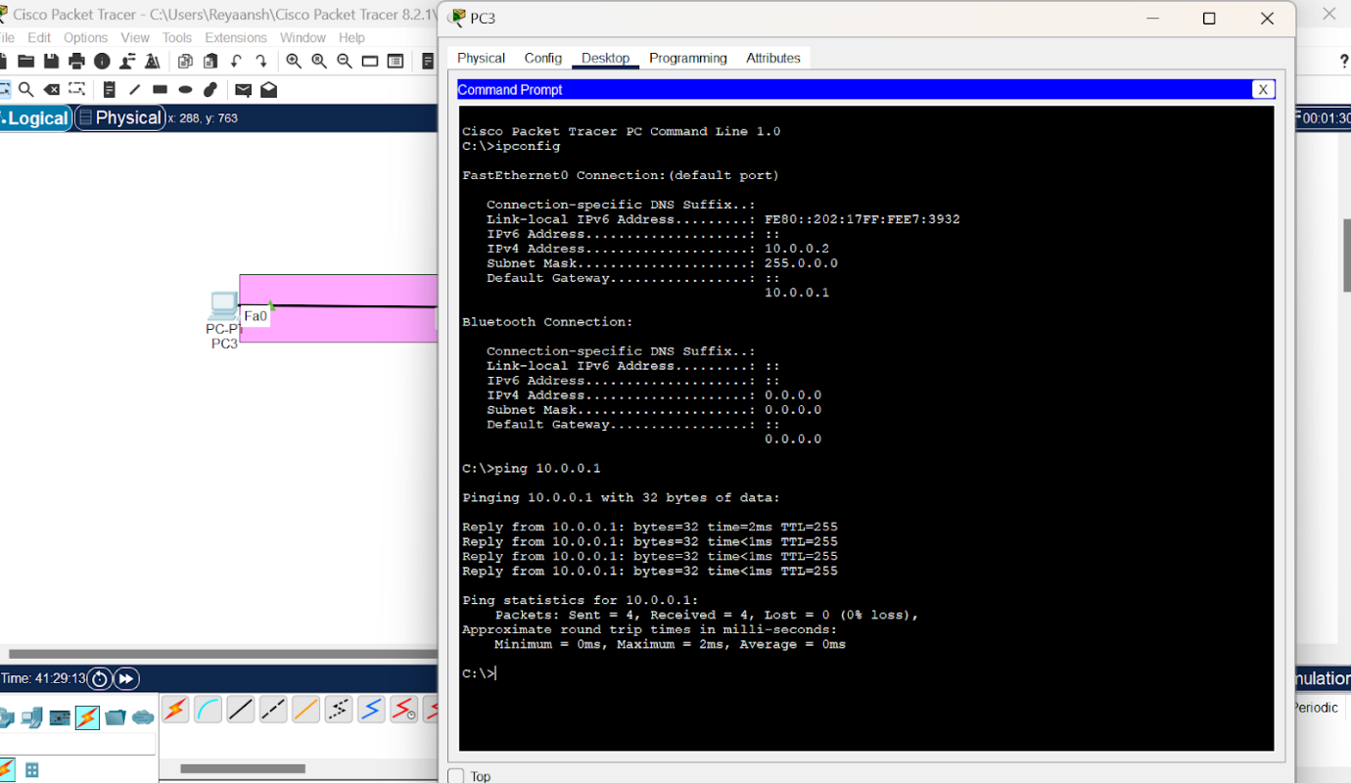

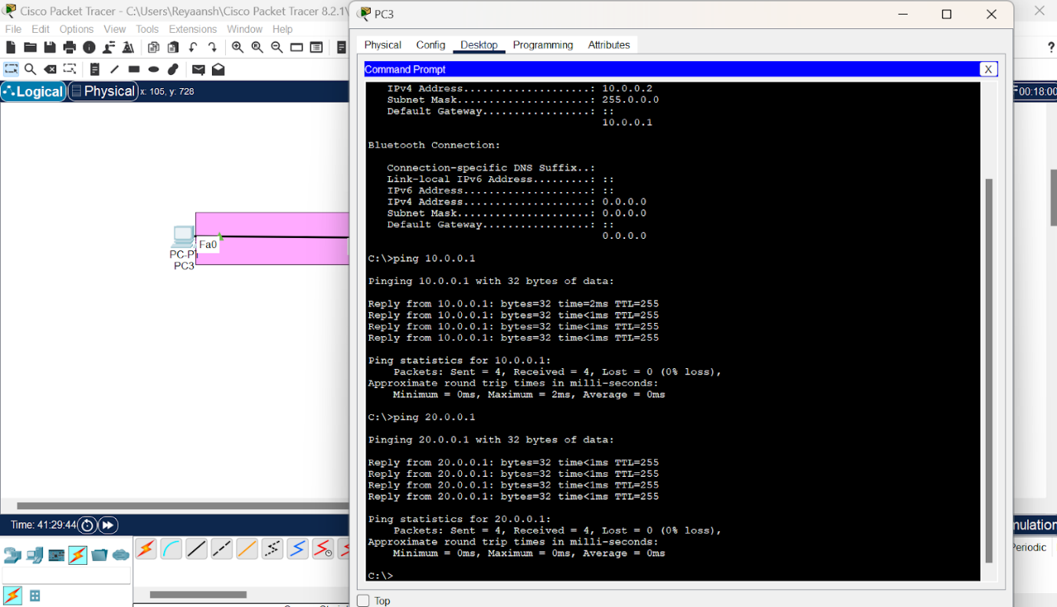

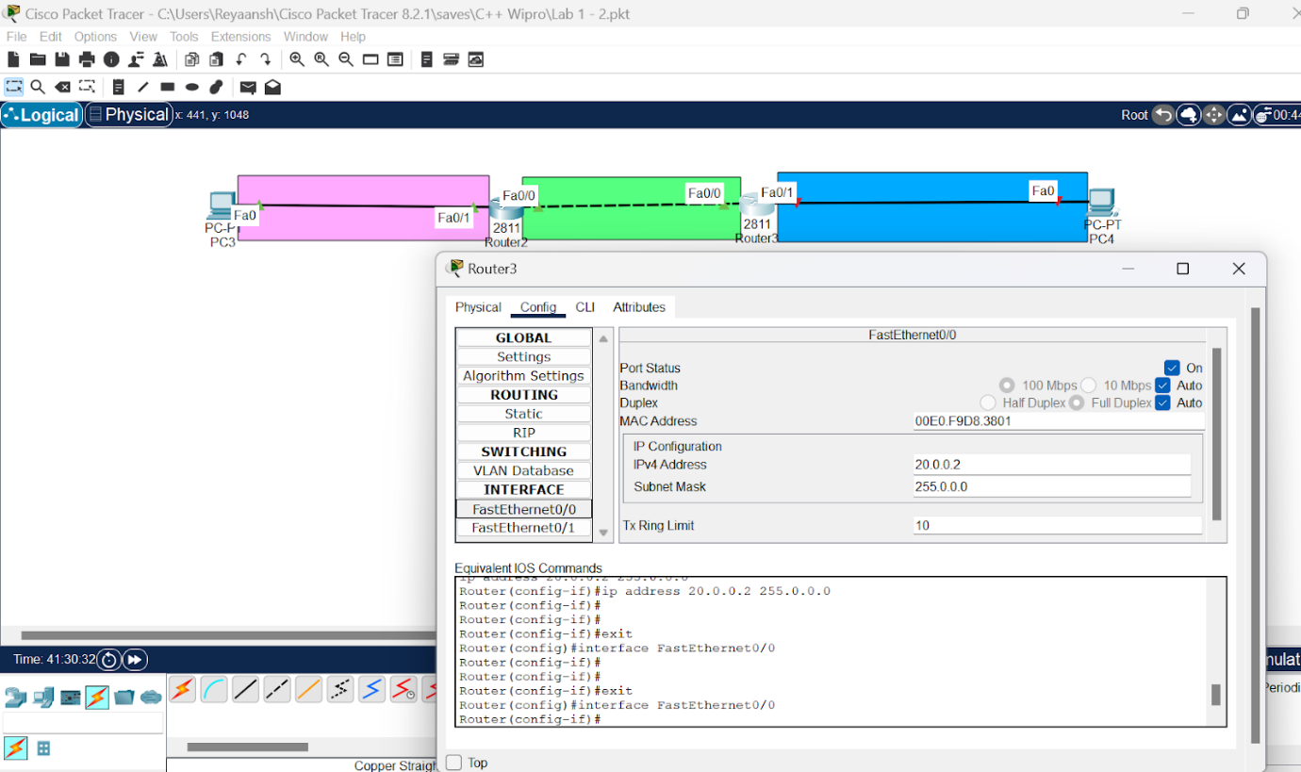

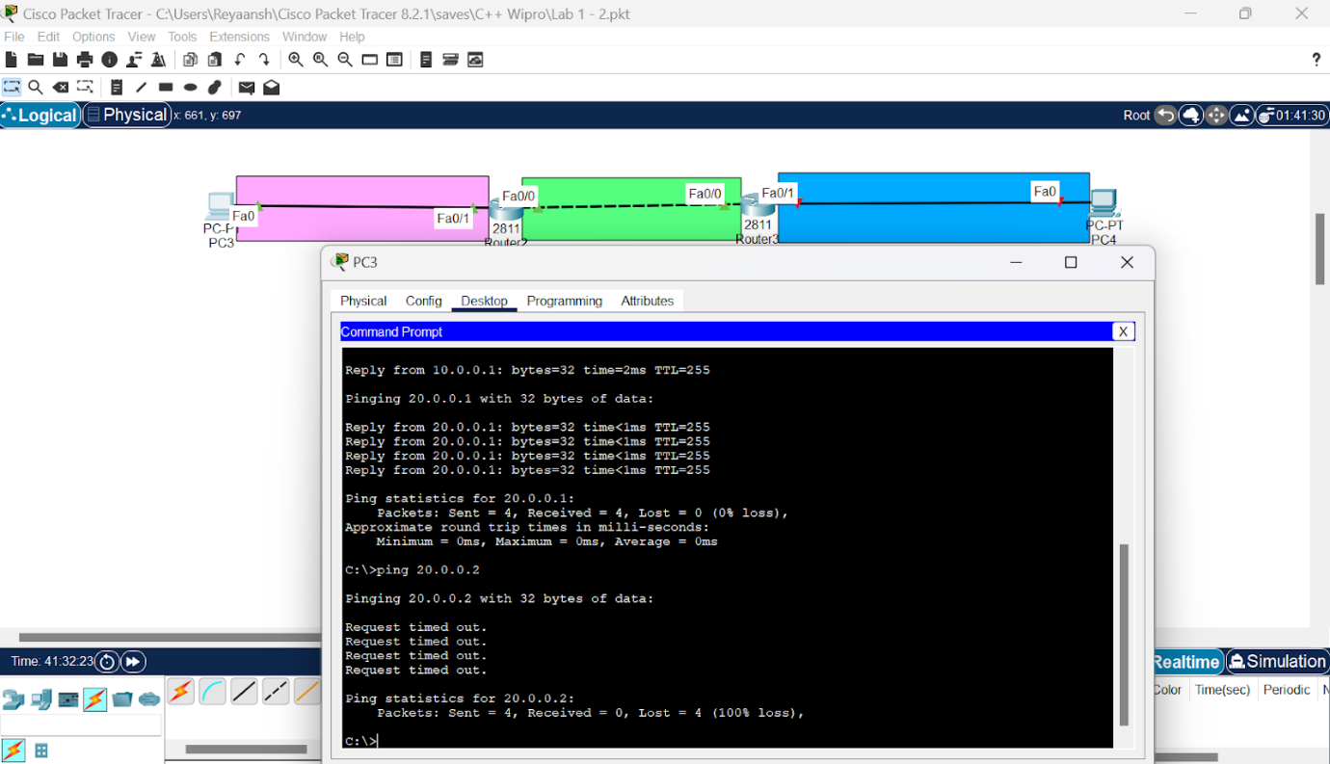

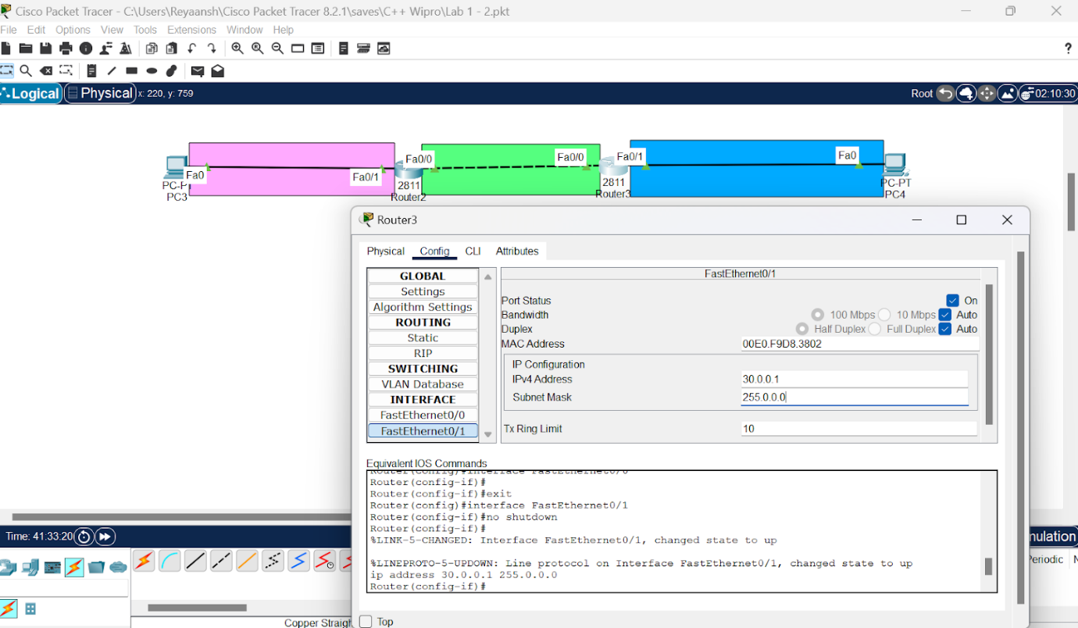

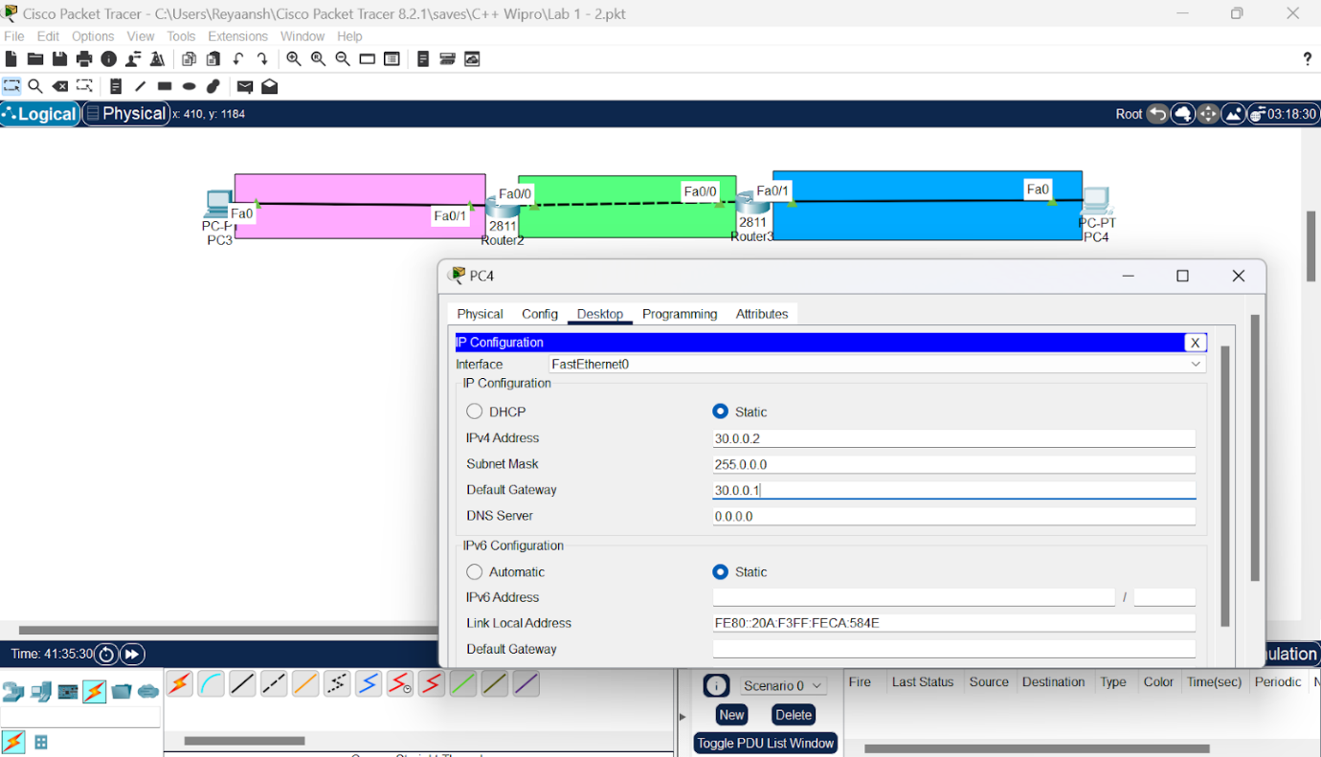

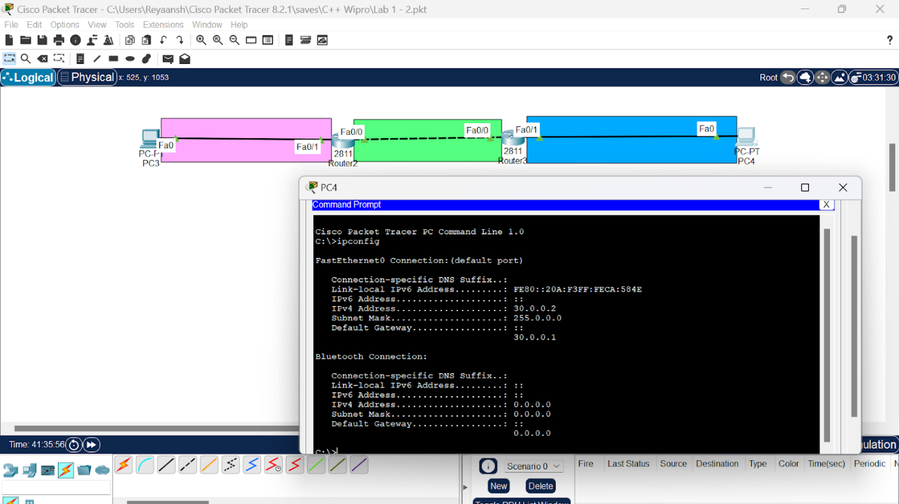

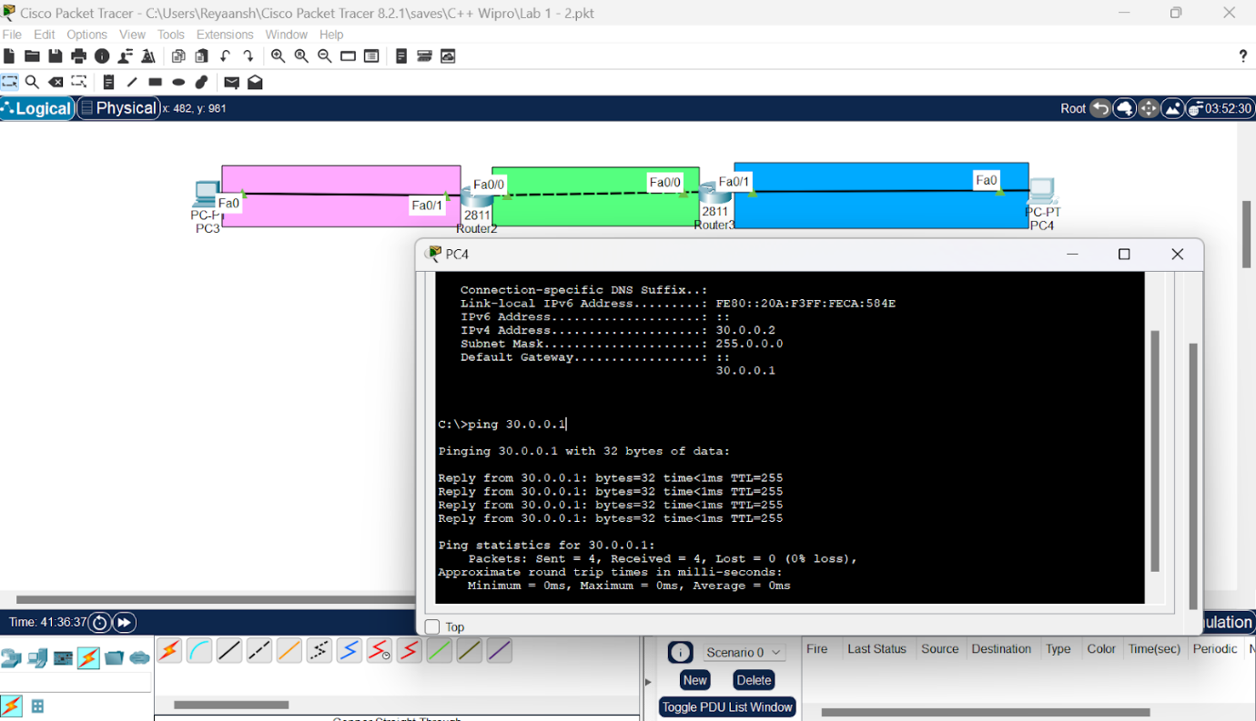

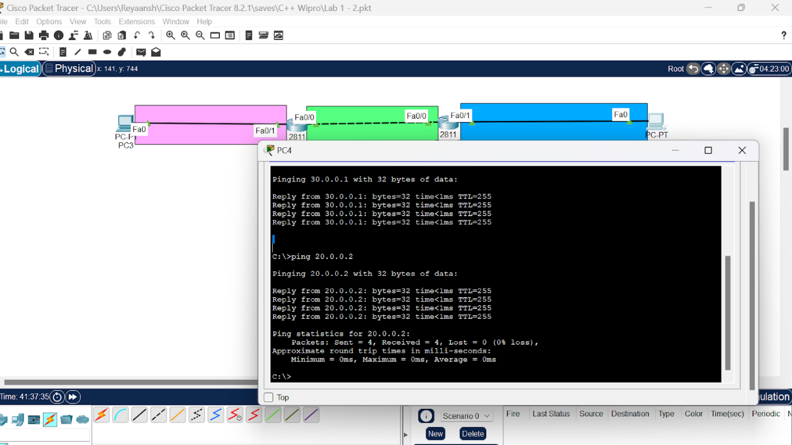

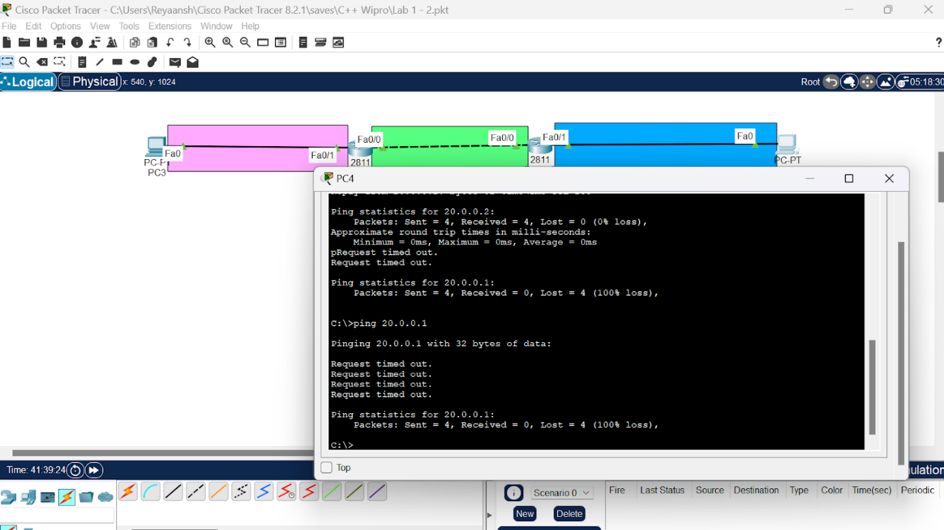

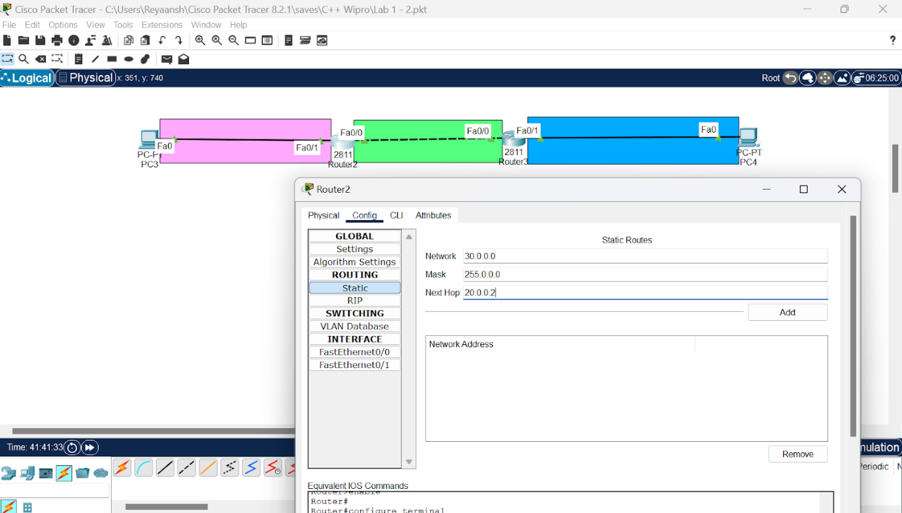

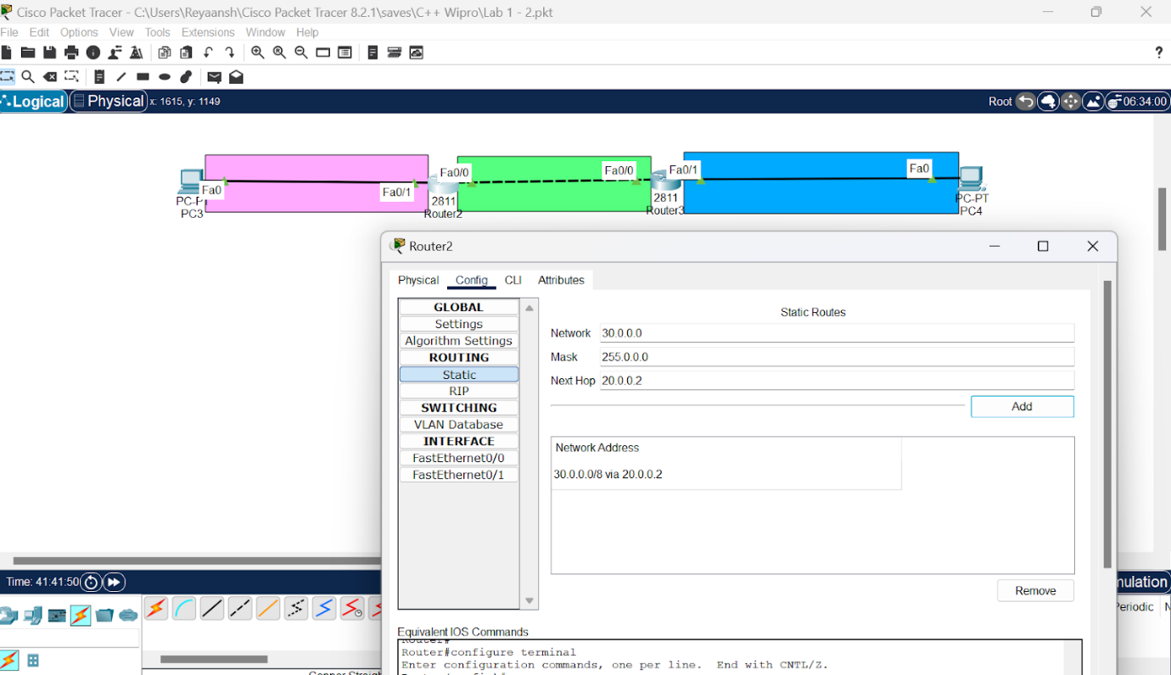

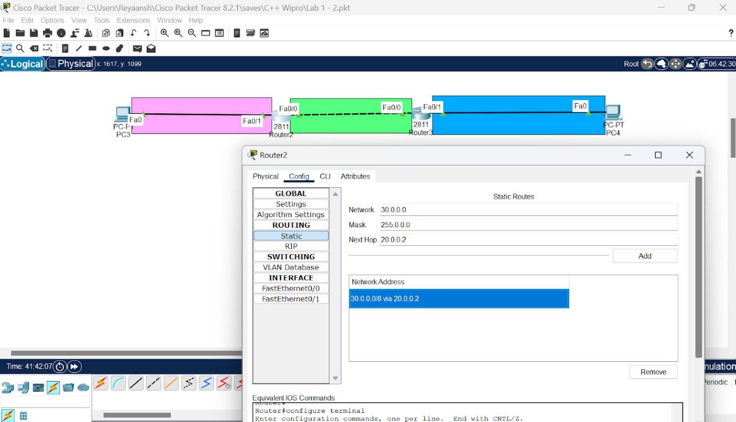

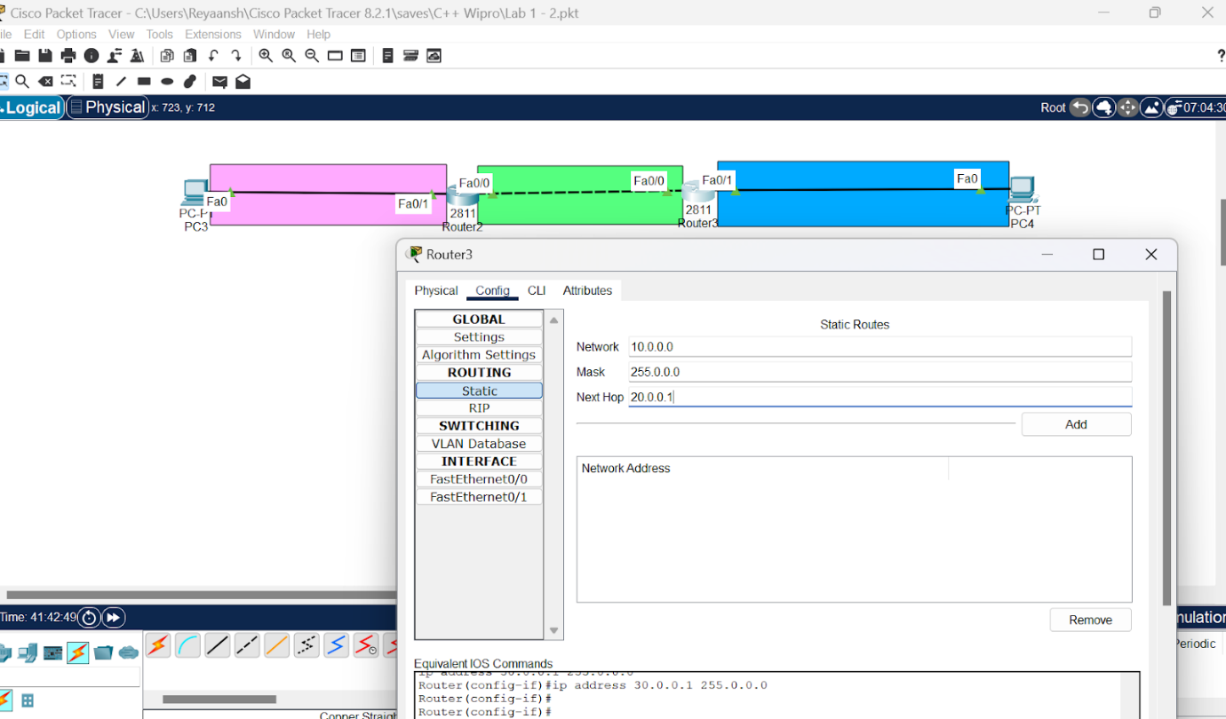

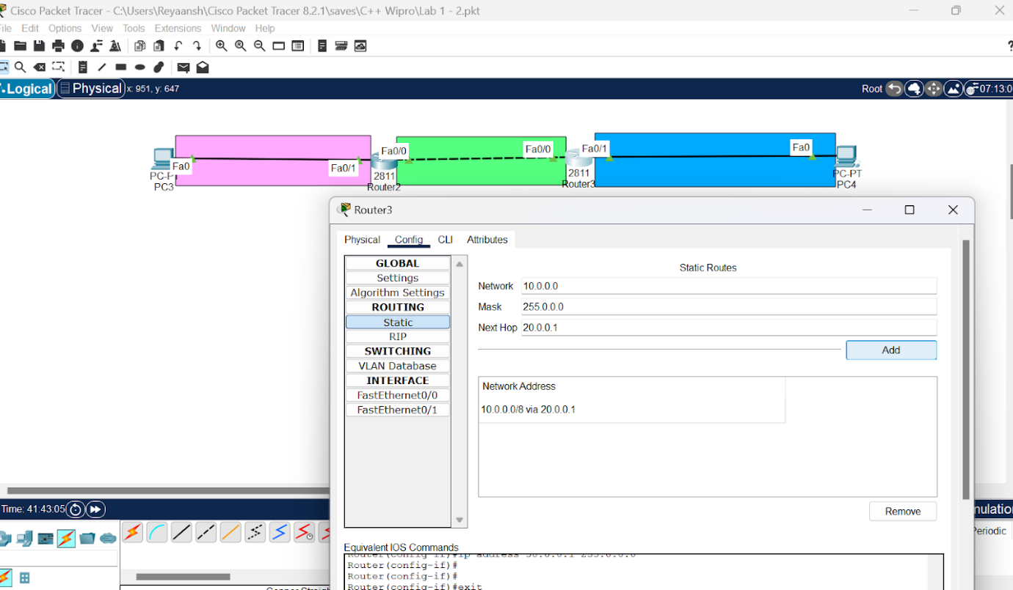

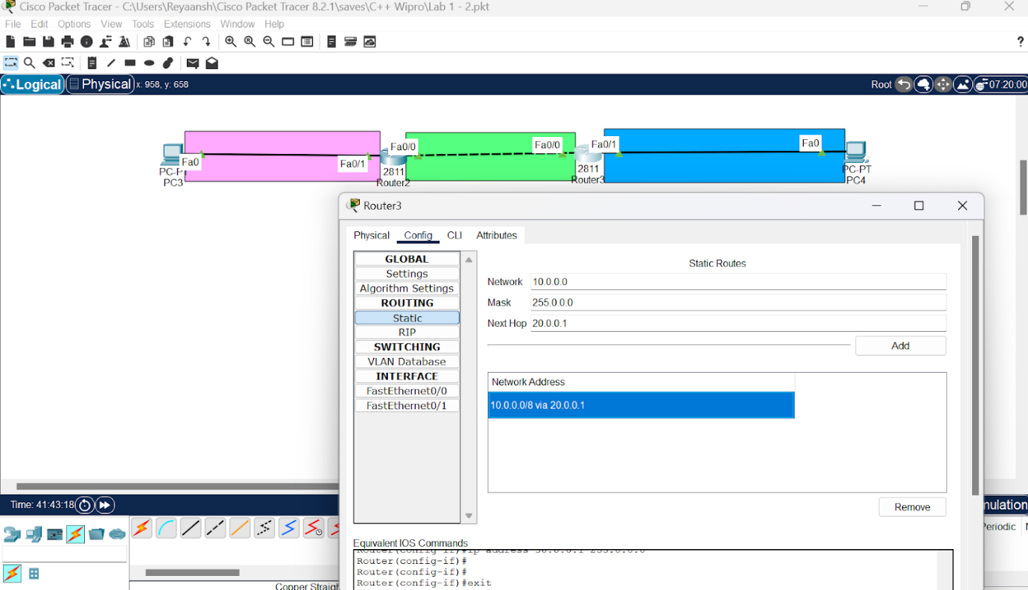

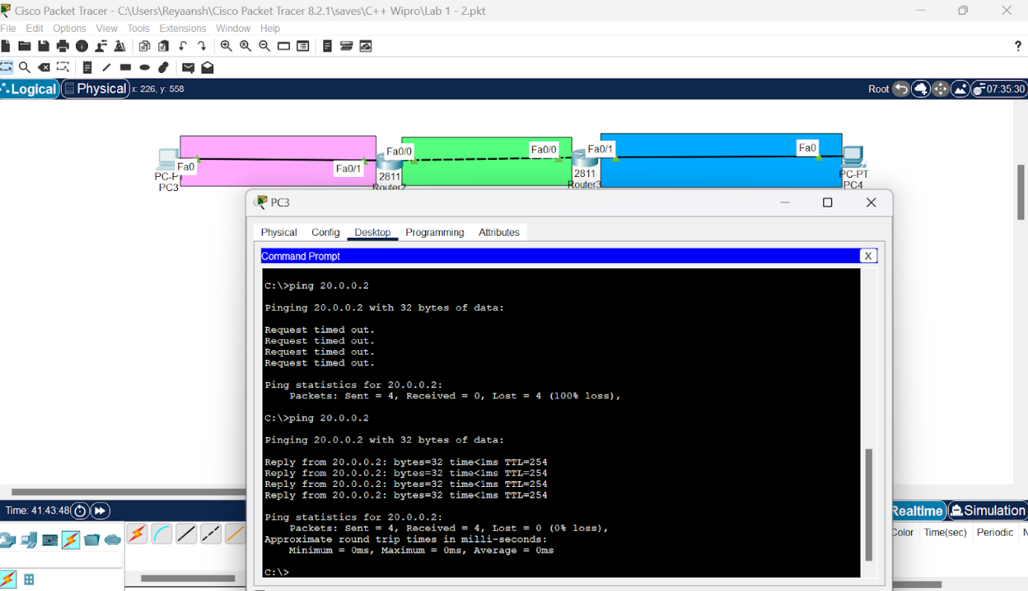

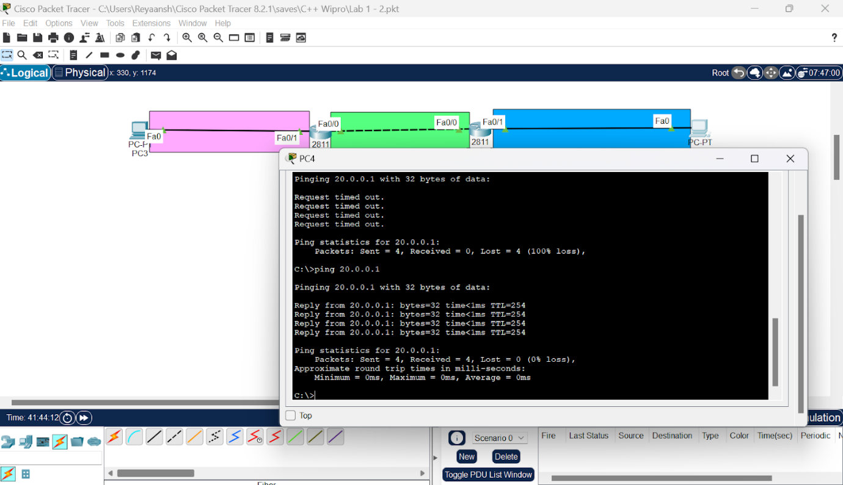

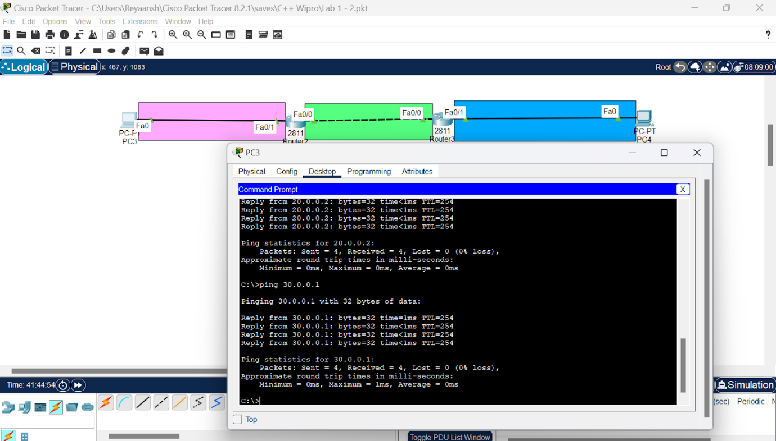

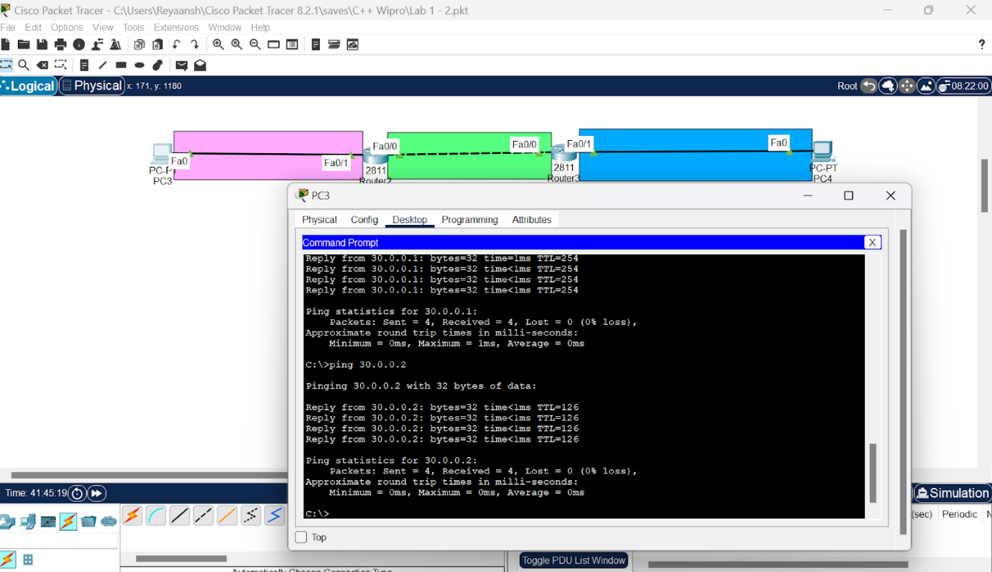

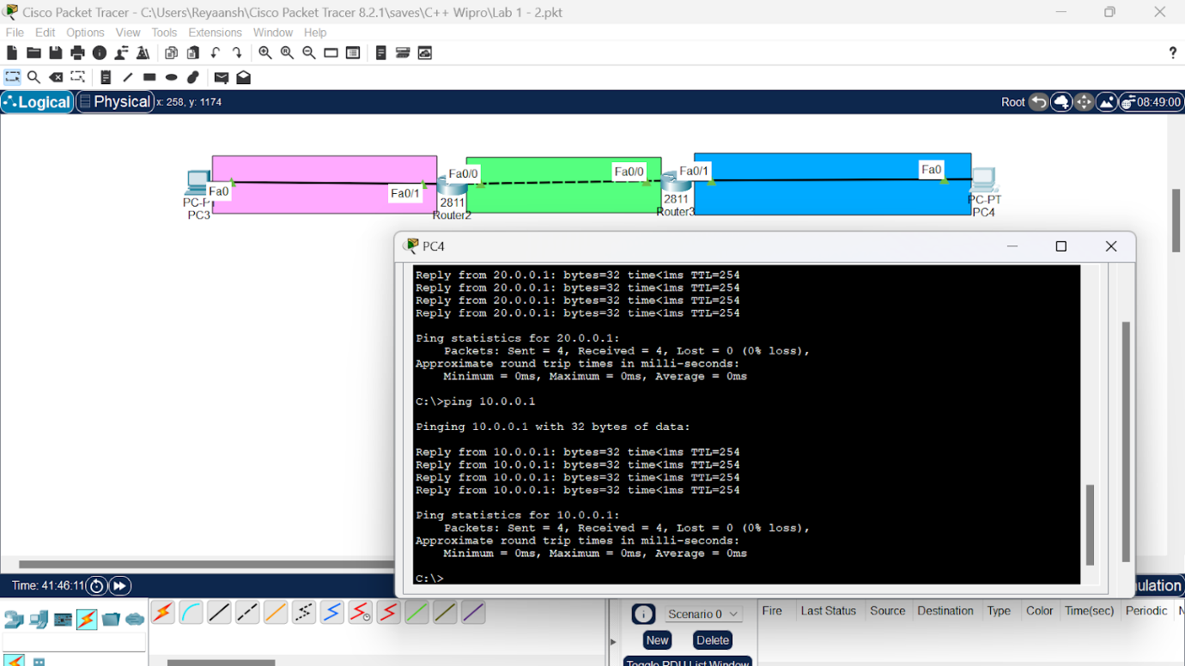

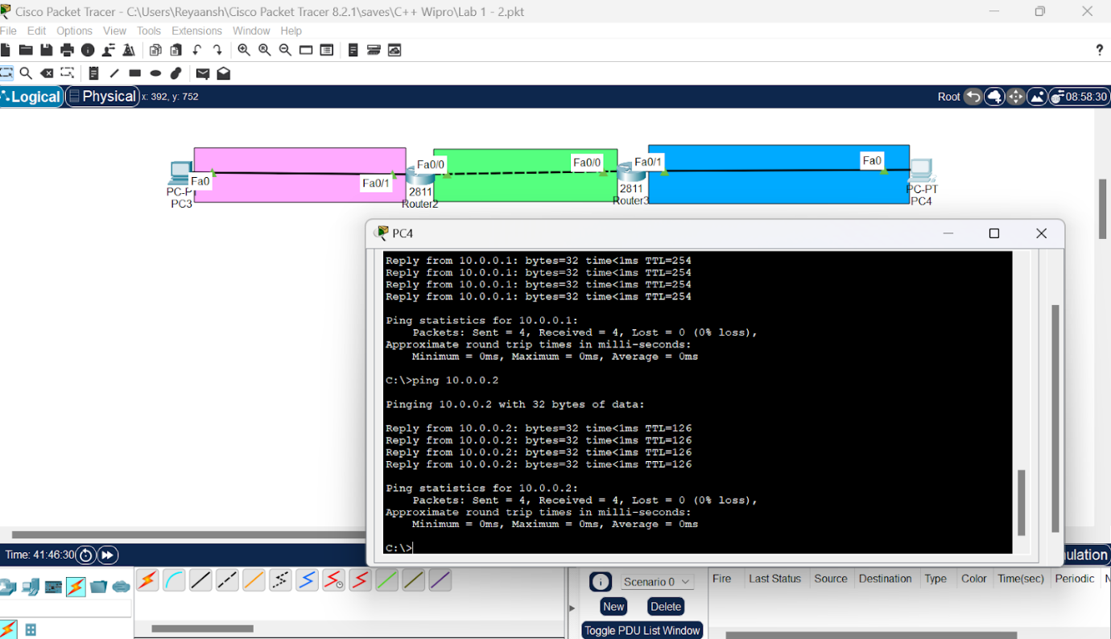

**Lab 5:Static (3 routers)**

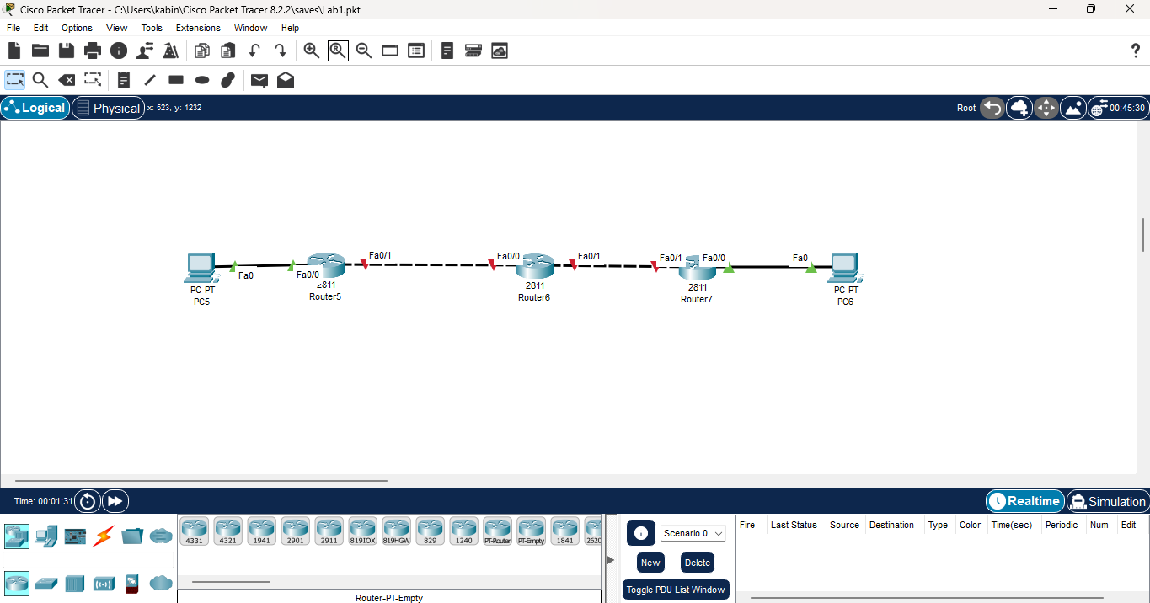

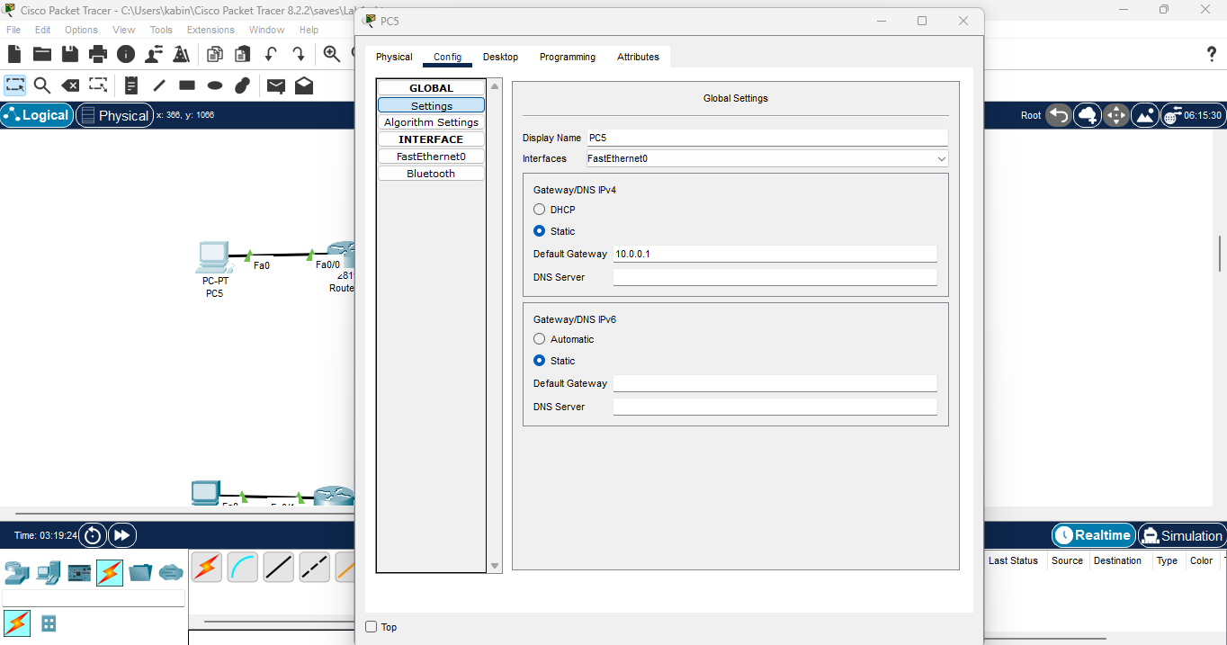

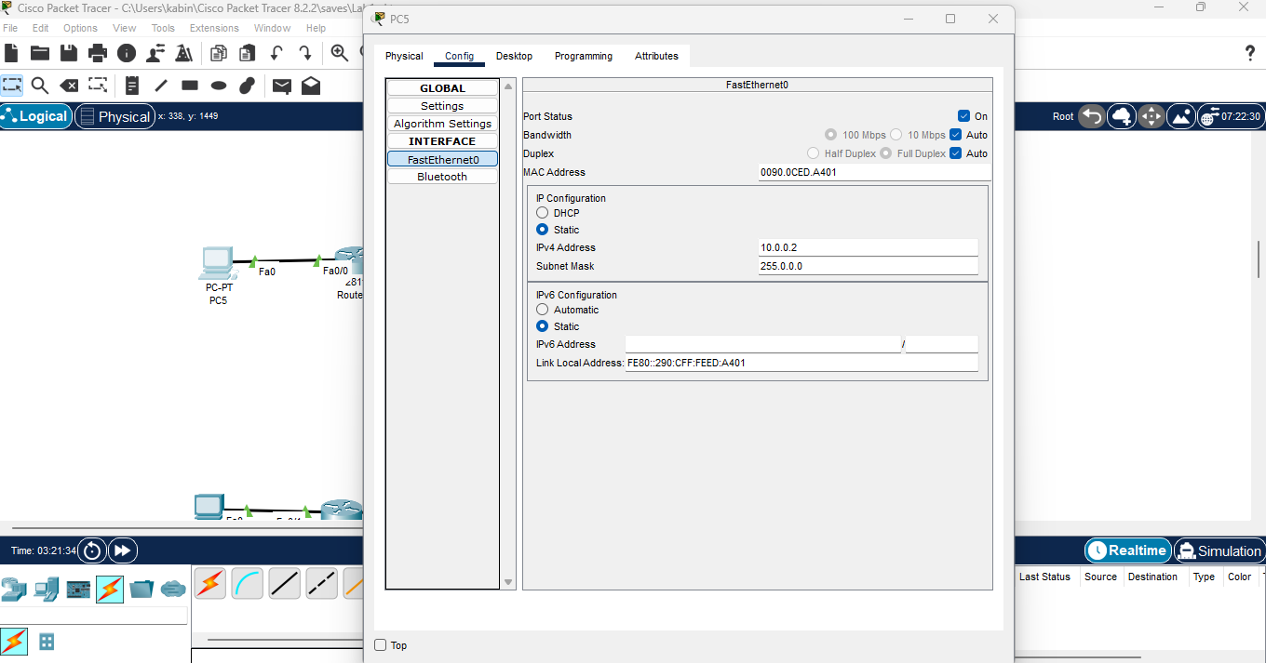

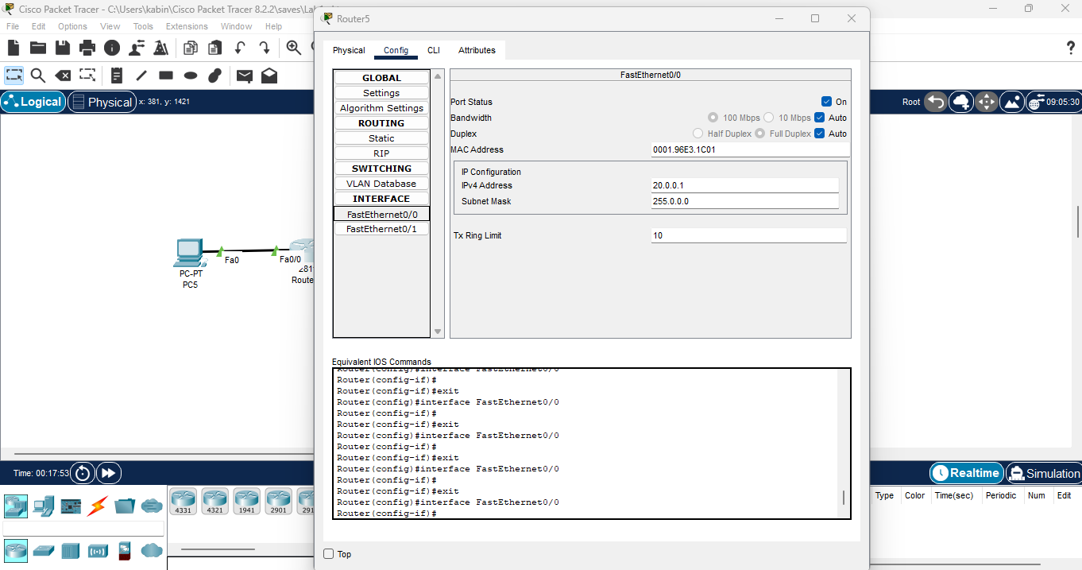

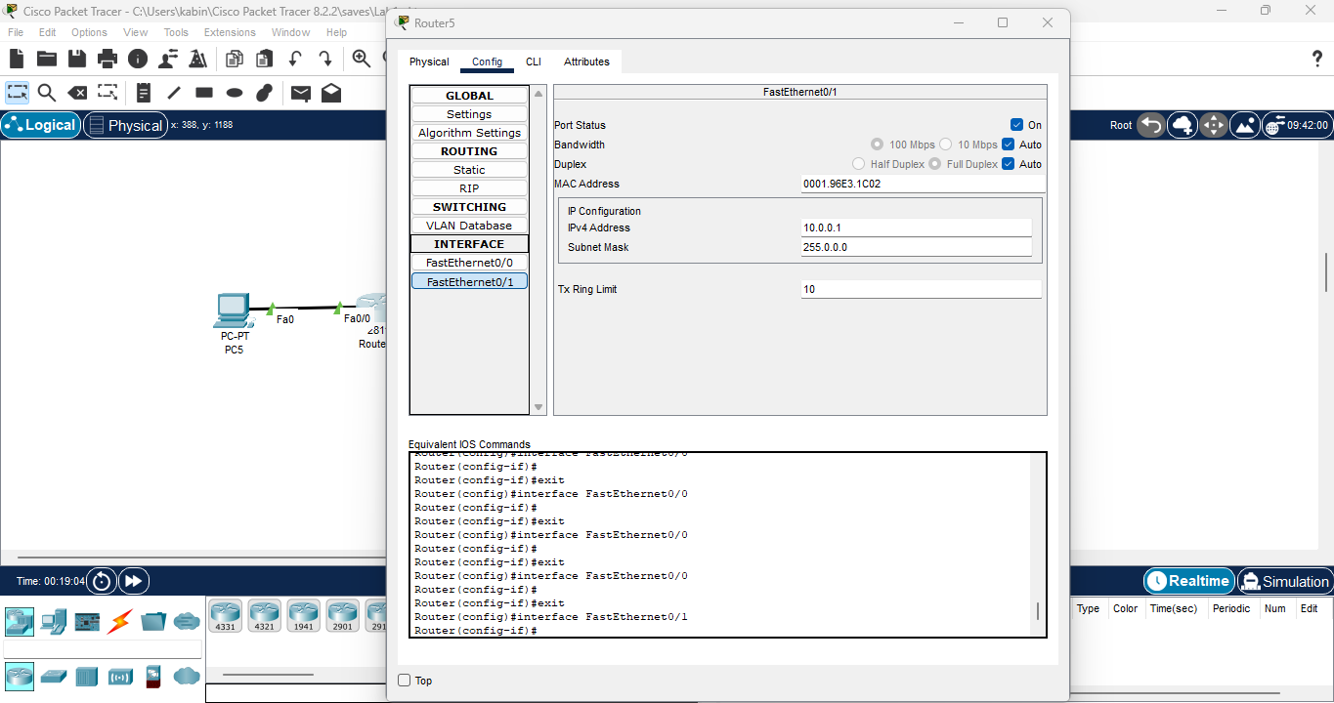

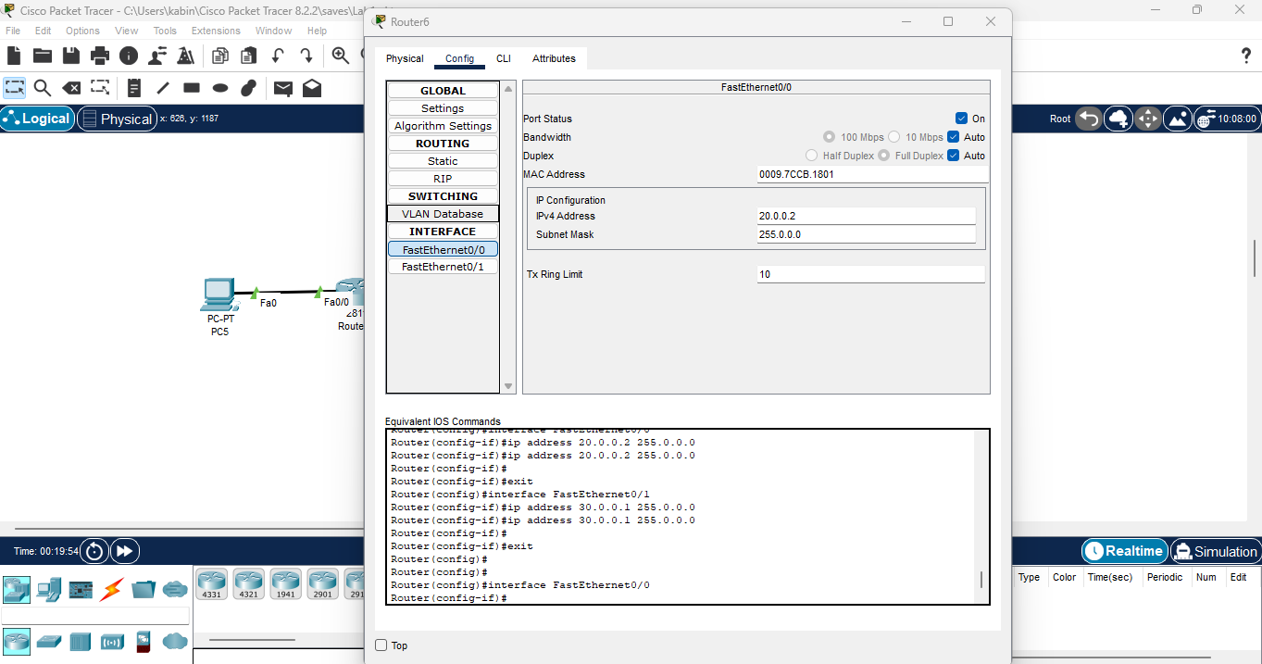

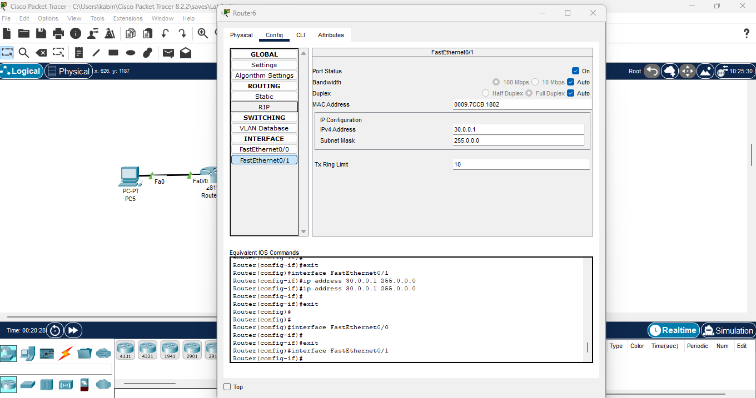

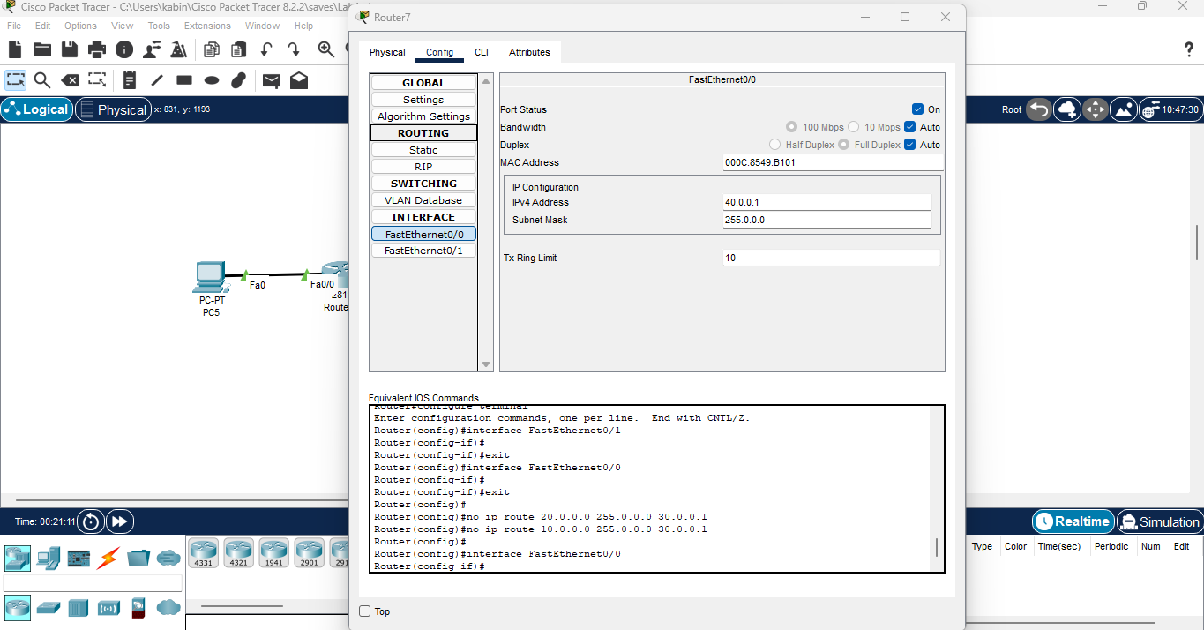

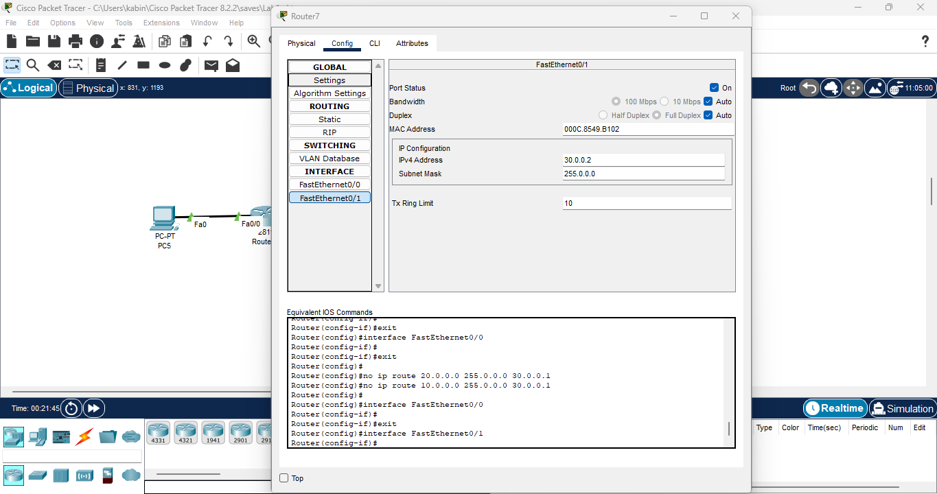

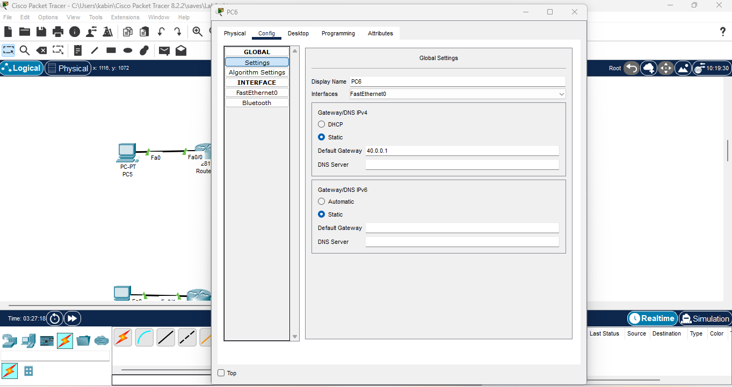

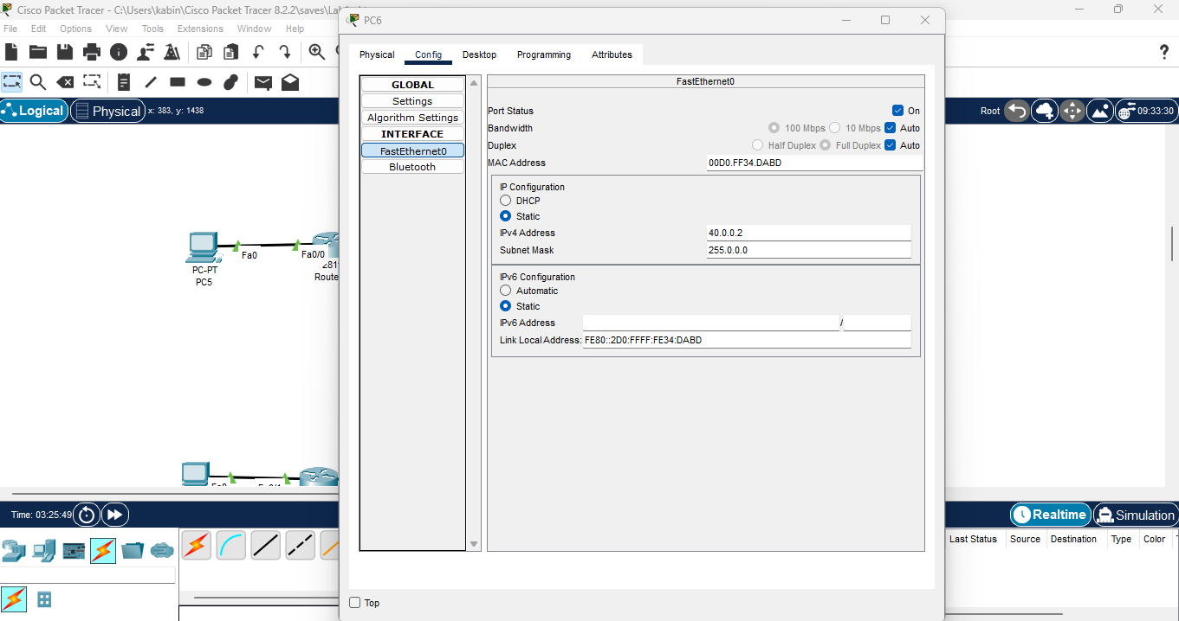

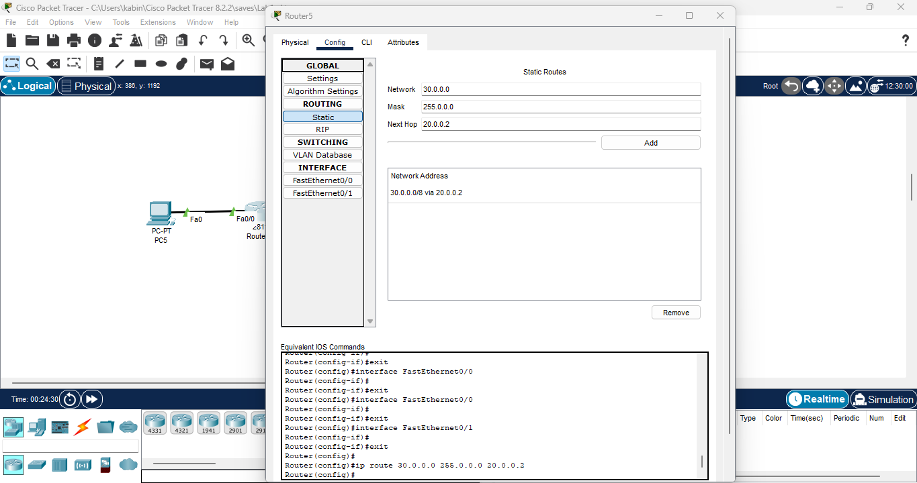

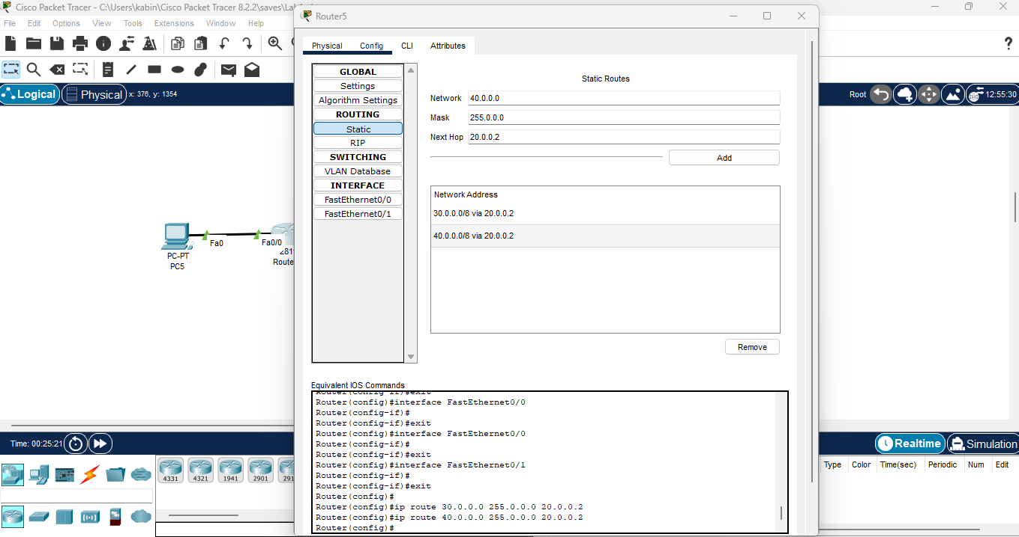

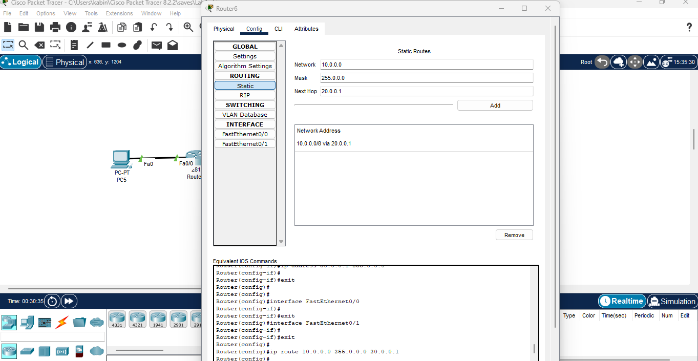

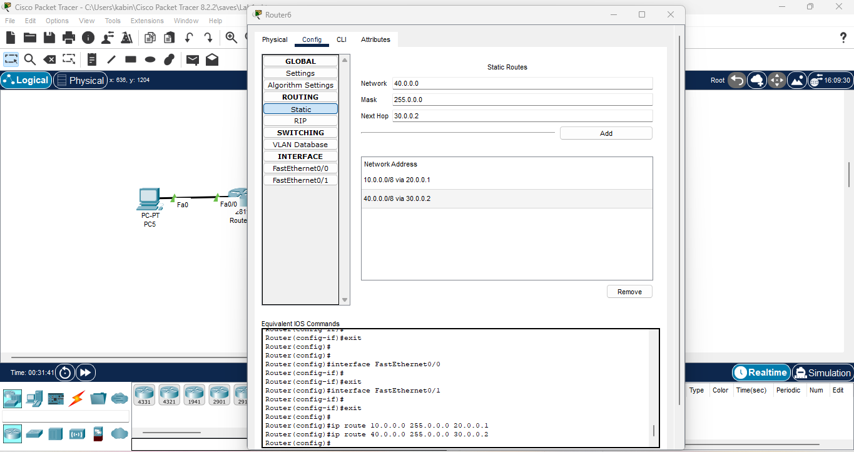

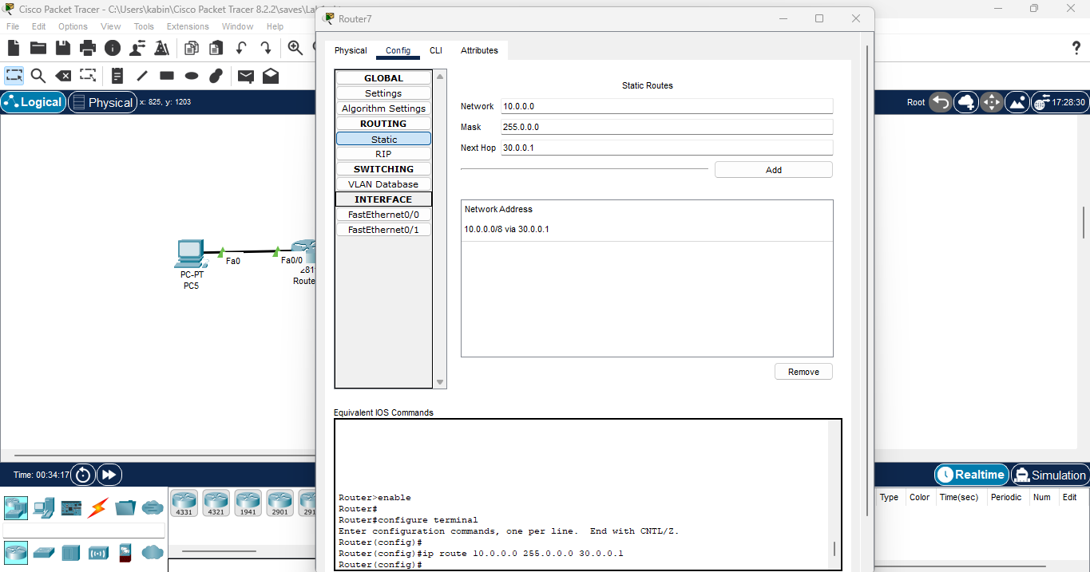

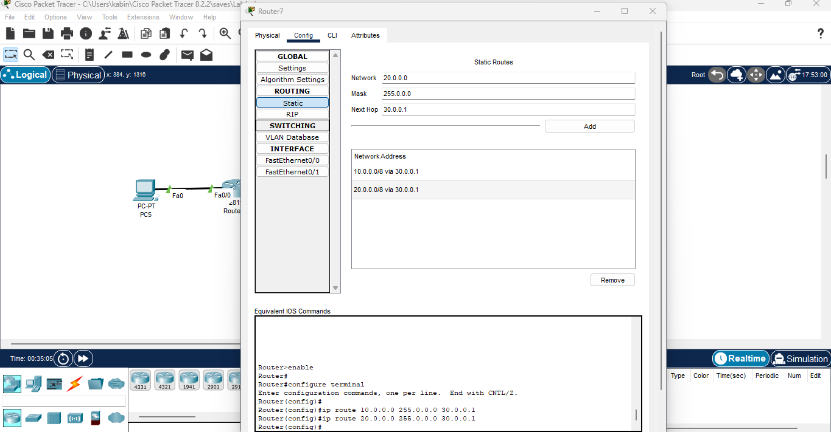

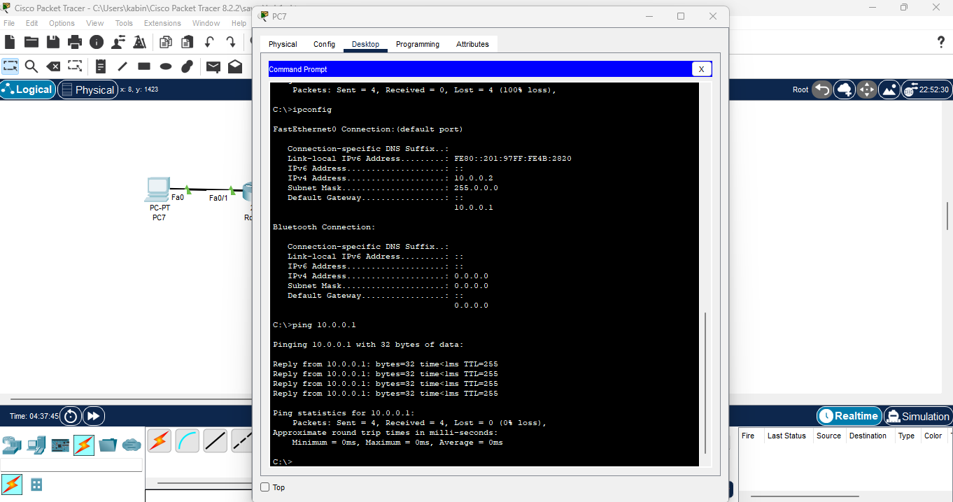

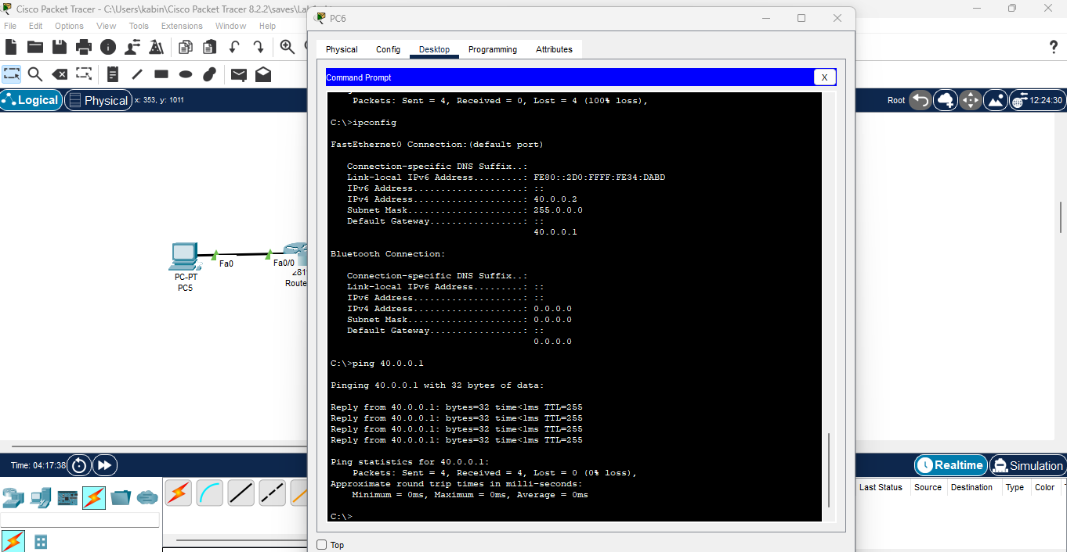

**Lab 6:Dynamic Routing**

